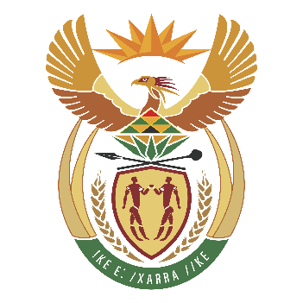
Committee: UNCSTD (United Nations Commission on Science and Technology for Development)
Agenda Item: The Role of Technology in Combaiting the Climate Crisis
Country: Republic of South Africa

In Africa, the effects of the climate crisis are becoming more and more painful and affecting the daily lives of many communities across the continent.Weather conditions, which were once daily sunny, are now unpredictably bad. Making it harder for people to plan their routines and rely on natural resources. Rising temperatures and pressure on water supplies show how climate change is already shaping daily challenges and pushing communities to adapt to a rapidly evolving environment in their everyday lives in meaningful ways. The climate crisis in Africa manifests itself with temperature increases, irregular rainfall and decrease in water resources. Extreme climate events such as droughts and flash floods make both agricultural production and daily life difficult, increasing food security and infrastructure problems. Difficulties in accessing water, health risks and loss of income negatively affect living conditions in many regions.
For example Pretoria has serious problems such as excessive rainfall and flood risk due to the climate crisis, health problems and water scarcity risks. Climate crises in Cape Town are mostly ecosystem loss and water scarcity. And in Bloemfontein the most common climate crisis are drought and pressure on water resources. But every area of Africa have drought and water shortage. These problems affect the country badly in every way and always gives harm to the environment
For solutions we can use technology to combat the climate crisis. In Pretoria we can use early warning systems and smart drains for rainfall and flood risk. İn Cape Town we can find solutions for water scarcity for example we can use seawater treatment and smart water sensors. And we can use technology for Bloemfontein too, for drought making underground water sensors and we can use drones which is predicts the weather in advence. But as the Republic of South Africa and other contries, we know that we will not be able to make much progress with these solutions and problems, so we should gather as all the nations of the world and make a cooperations and development program.

REFERENCES:
- Climate Risk Profile for Southern Africa (PDF): https://weatheringrisk.org/sites/default/files/document/Climate-Risk-Profile_Southern-Africa.pdf
- WRC – Climate change and water resources in South Africa (PDF): https://www.wrc.org.za/wp-content/uploads/mdocs/14302.pdf
- MDPI – Management of Water Resources in South Africa: https://www.mdpi.com/2300-7575/25/4/50
- CSIR ResearchSpace – Impacts of climate change on water resources: https://researchspace.csir.co.za/bitstreams/ea16f0a4-9f4f-41f0-98de-39df50cd5154/download
- Rainfall extremes are becoming more probable in parts of SA’
https://www.up.ac.za/news/rainfall-extremes-are-becoming-more-probable-parts-of-sa-meteorology-experts
- South Africa’s major climate threats — from drought to deadly heatwaves
https://mg.co.za/the-green-guardian/2025-10-09-south-africas-major-climate-threats-from-drought-to-deadly-heatwaves/

