Comitee:WHO (World Health Organization) 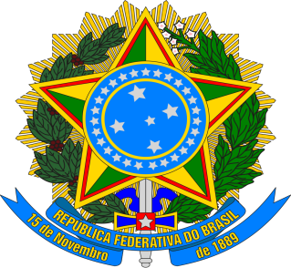
Agenda Item:Addressing Health Issues Caused by Air Pollution
Country:Federative Republic of Brazil
Brazil, officially known as the federative republic of Brazil, is a federal republic governed by a presidential regime.It’s capital is Brasilia.Brazil, which has been independent since September 7, 1822, has a surface area of 8,515,770 square kilometers.The officially language of Brazil is Portuguese, and the official religion is 87% Christian, 8% atheist and 5% is unknown.Brazil’s neighboring countries are Argentina and Paraguay to the southwest, Bolivia and Peru to the west, Colombia to the northwest and Venezuela and Suriname to the north. Brazil rose to 15th place in the ranking of the world’s dirtiest countries due to various problems and was ranked 4th in the list of people who died most from air pollution in 2018.
The biggest reason for these events is Brazil’s developed and developing factories and indudtries. Air pollution from factory fumes has exceeded 75%.One of the biggest solutions to this problem could be the installation of electrostatic precipitators, bag fiters and gas scrubbers.However,8% of Brazil’s air pollution comes from vehicle exhaust fumes.17% comes from human behavior, both conscious and unconscious.For example, cigarette smoke, the use of harmful , unsafe fuels and improper industrial waste disposal are responsible for thousands, even millions, of deaths in Brazil.At the same time, healthcare services in Brazil are in a very poor state.Unfortunately, the Brazilian budget does not cover hospital and hygiene expenses, and the number of people dying in hospitals due to pollution is increasing daily.For this reason, the experience of Brazilian hospital doctors is debatable.For this reason,it may be recommended that hospitals pay more attention to hygiene.Due to inadequate sanitation conditions hygiene in hospitals and high levels of air pollution outside,babies in the womb may be born prematurely or with mental disabilities.
Although there are so hundreds of Amazon rainforests in Brazil, none of them are beign protected safely or cared for.As a result, some animals living in the Amazon forests can be harmed by individuals involved in unlawful activities. The most important thing we can do to prevent this is to inform the Brazilian authorities and keep nature clean. In fact, many animals are dying in the Amazon rainforests due to air pollution.And, of course,exhaust fumes from vehicles. In Brazil, many people buy gasoline or diesel vehicles because there are not enough charging stations polluting the environment.To prevent this, more electric vehicle charging stations could be built in Brazil. REFERENCES
https://aqicn.org/map/brazil/tr/
https://ourworldindata.org/

