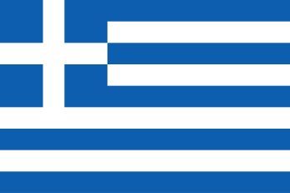
POSITION PAPER
GREECE
Committee: United Nations Security Council (UNSC)
Subject: The Situation in Sudan

As a result of the conflicts in Sudan, millions of civilians have been deprived of food, clean water, health services, shelter, and security. In addition, banking systems, communication infrastructure, and public services have become dysfunctional, further deepening the humanitarian crisis. The solution that the United Nations must find should be based on these security measures.
This situation poses a serious threat not only to Sudan but also to regional and international security. The weakening of state authority has led to the strengthening of armed groups, an increase in illegal trade, and mass migration.

Greece supports Sudan's sovereignty and territorial integrity. However, protecting civilians is as much a priority as protecting state structures. Greece believes that the strengthening of non-state armed groups will increase instability in the long term. Therefore, Greece strongly opposes the existence of these groups.
Greece also argues that attacks on civilian infrastructure and humanitarian aid workers are unacceptable and a clear violation of international humanitarian law.

According to Greece, the most critical aspects of the crisis in Sudan are: to deliver humanitarian aid to civilians
Damage to hospitals, water systems, and electrical infrastructure
Collapse of communications and digital systems
Loss of access to financial systems

Greece believes that the Security Council should focus on the following areas:
Ensuring humanitarian access: All parties must allow humanitarian aid to reach civilians. Safe humanitarian corridors must be established.
Restoring basic services: The international community must support the restoration of health, water, energy, and communication systems.
Protection of financial and digital access: Secure and impartial financial systems must be supported to enable civilians to access humanitarian aid.
Diplomatic solution and stability: The conflict must be resolved through diplomatic initiatives, not military means, and the stability of Sudan's state institutions must be ensured. I would like to reiterate Greece's commitment to stability.

Greece reiterates that the crisis in Sudan is not only a military one, but also an institutional and humanitarian collapse. The Security Council's task is not only to stop the conflict, but also to protect the systems that ensure the survival of civilians. Greece is ready to develop realistic and sustainable solutions in cooperation with all delegates.

