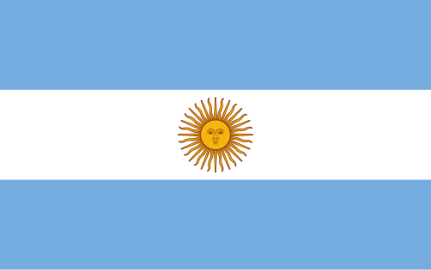
Committee: UN Women
Country: Argentina
Agenta Item: Protecting Women in the Age of Digital Abuse: Regulating Al, Deepfakes, and Online Gender-Based Violence.

Argentina is a federal democratic republic located in South America. It has a complex history, having experienced colonialism, political instability, and the process of democratization. It gained independence from Spanish rule in 1816 but struggled for a long time with military coups and authoritarian regimes. It transitioned to democracy in 1983, marking a significant turning point. With this transition, Argentina has focused on strengthening the constitutional order and emphasizing active cooperation. Argentina also faces some internal problems. Structural issues such as social inequality and economic instability have a direct negative impact, particularly on women and vulnerable groups. At the same time, Argentina has a strong history of women's movements, playing an influential role in shaping policy. By becoming a signatory to CEDAW in 1985, Argentina demonstrated its commitment to women's rights as an integral part of human rights.
The spread of digital technologies in recent years has fundamentally changed access to information and communication. The resulting environment has led to the spread of gender based violence against women. Violence facilitated through technology has increased its impact and deepened gender inequalities. With digital spaces becoming central to life, online harassment, deepfake technologies, and the sharing of images without consent constitute violations of security and fundamental human rights. These forms of digital abuse threaten fundamental human rights, including the right to privacy, the right to personal security and the right to equal participation in public spaces. The digital violence affects women on an individual level while also limiting their participation in social spaces and weakening their democratic participation. Combating this violence, which is used both to exploit and intimidate women and directly undermines human dignity, has become a global issue.
Argentina evaluates digital gender based violence within a broader context. This form of violence constitutes a continuation of ongoing violence against women. Argentina supports the adaptation of existing legal frameworks and policies to address new threats while simultaneously protecting democratic principles and freedom of expression. Argentina is a country committed to CEDAW and human rights obligations, emphasizes the importance of protecting freedom of expression and the democratic environment in digital spaces.
Certain challenges may be encountered in regulating artificial intelligence and deepfake technologies. The rapid development of artificial intelligence overwhelms the capacity of legal systems to respond and makes it difficult to draw necessary conclusions. This allows perpetrators to go unpunished and creates an environment of distrust.
In this context, Argentina is aware of the responsibilities that platforms must undertake, viewing them not merely as neutral tools but as responsible factors, and adapting an approach that supports survivor-centered systems rather than perpetrator-focused one. These approaches are considered fundamental in ensuring transparency and security. Argentina also supports international cooperation and efforts to make responses and measures to digital violence more effective. Given the global impact of digital platforms, international cooperation is essential for an effective solution.
In conclusion, ensuring women’s safety in digital spaces requires a human rights based approach political will for a long term solution, and international solidarity. Argentina believes that UNWOMEN plays a critical role in facilitating cooperation and supporting intergovernmental efforts, as well as promoting women-centered policies.

UN Women. (n.d.). Country profile: Argentina. United Nations Entity for Gender Equality and the Empowerment of Women.
Convention on the Elimination of All Forms of Discrimination against Women (CEDAW). (1979). United Nations.
United Nations General Assembly. (n.d.). Resolutions on violence against women. UnitedNations.
UN Women. (n.d.). Ending violence against women in digital spaces: Policy and advocacy frameworks. United Nations.

