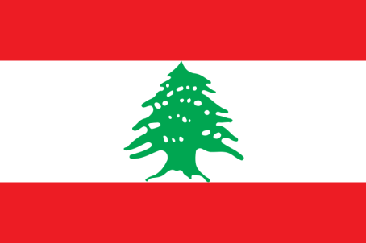
Country: Lebanon
Topic: Preventing the second Covid-19 wave in African Region
Committee: World Health Organisation(WHO)
Delegation: Elif Nur Avcı
Lebanon is located in Western Asia,on the East Mediterrean coast.Syria lies to the North and East and Israel to the South.Population is around 6.849million according to the datas in 2018. All schools in Lebanon are affiliated with National Education.According to a report prepared by the USA in 2005, half of 140.000 students in Lebanon are students in Lebanon are studying at the Lebanese University, and the other half at 42 private universities. The Lebanese economy displays a service-oriented structure.

In 21 February Lebanon confirmed its first case of Covid-19. On 10 March the first covid-releated death in Lebanon was recorded. On 11 March Rafik Hariri University Hospital announced the second death. There we also 9 new cases. The first fully recovered patient was also announced.On March 15, 6 new cases were announcced and the total number reached 99. Lebanon declared a state of medical emergency. On 26 March, Lebanon imposed a partial curfew from 7 p.m. to 5 a.m. i order to slow the spread of the virus. According to statistics, while case increases in Lebanon increased with a maximum of 60 new cases per day until July but there was a significant increase after July.

Over the four weeks up to 21 October, there was a 4% average increase in new cases, according to the Africa Centres for Disease Control and Prevention (Africa CDC).There were average increases over the month across all the regions except in west Africa.Data from Africa CDC shows over the past month, cases on average increased by 42%.
United Nations Secretary-General Antonio Guterres states that Africa needs a lot of materials such as test kits, masks, respirators, protectors and says : "Africa needs a massive mobilization. Otherwise, millions of people will die."
Assuming these case increases could cause a second wave in the African Region, other countries around the world can come together and provide financial and moral support to Africa. Countries in good condition and decrease in Covid cases can send to Africa for test kits and medical suppliments to avoid this second wave.
During these challenging times; as the representatives of Lebanon we are open to collaborations to work on solutions in order to make our world a better place.

