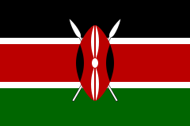 | 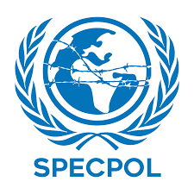
Committee:SPECPOL (The Special Political and Decolonization Committee) Country: Kenya Agenda Item: Administration of Cultural Heritage
Kenya is one of the East African countries with a population of 53.7 million. The capital of Kenya is Nairobi. Kenya has two languages which are commonly spoken: English and Swahili. Kenya’s main source of income is agriculture. Although only 20% of the land is suitable for agriculture, cultivation of crops such as coffee, tea, sisal, and pyrethrum is carried out in limited areas. Once an exploited country, Kenya gained its independence in 1963.
We are highly aware of the importance of our cultural heritage. In order to solve this problem, The constitution of Kenya and national policies mentions this and highlights that it must be protected. Our government plays an active role in promoting the protection of cultural heritage, seeing it as the key to our national identity. Kenya acknowledges cultural heritage as a key to economic driver. Because tourists buy local goods and such and this contributes to Kenya’s economy. Our country organizes festivals to raise awareness, educating tourists to prevent harming the ancient artifacts and promotes local work. Kenya also supports cultural and sustainable tourism in order to offer jobs to locals, preserves the environments and nature while allowing tourists to travel, focuses about their experiences and enjoy the culture of Kenya. Kenya also actively engages with UNESCO’s cultural problems and heritage convention. Our country participated to UNESCO’s heritage committee and we host conferences about global preservation. Kenya supports repatriation conversations with UNESCO including bringing back artifacts that were taken from the country. Kenya engages with the locals, raising awareness about our heritage sites and highlighting the importance of why they should remain untouched. Kenya respects the traditions among the locals and protects them by these regulations and policies. Kenya limits visitation to these sites which represent our heritage in order to protect them. Kenya also supports other countries, signing reaties with them. We carried out such agreement in 1972, The World Heritage Convention with UNESCO.

We call on all the countries to address this problem. As we mentioned before, our culture is our identity, our economic driver. Our past and our sites must be protected. We can raise awareness to tourists and educate locals to protect our culture. We highly believe in teamwork and collaboration. We can overcome this problem by uniting and working together efficiently.

