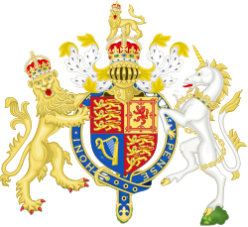
Country}United Kingdom (UK)
Committee}World Health Organization

Agenda Item}Addressing Health Issues Caused By Air Pollution

The United Kingdom is a highly industrialized and a crowded country with a population of over 67 million people, where air pollution remains a serious public health and environmental issue for United Kingdom. And particularly for crowded cities due to high levels of traffic and population because UK is a popular country around the world. Long term exposure to polluted air increases the risks of asthma, lung diseases, and heart problems which happens more often in children and elderly people. Even though the United Kingdom has a great healthcare system through the National Healthcare Service it is important to reduce pollution related illnesses should be prevented in order to eventually ease the pressure on public health services.

The United Kingdom has taken several national actions in an effort to reduce air pollution.For example,in London, the ULEZ aims at reducing vehicle emissions into the environment while national policies support cleaner energy use and reduced air pollution.Such efforts like that the UK views air pollution as both an environmental and health concern and is committed to take an act.

The government of the United Kingdom says it supports the role of the WHO in tackling air pollution.The UK is taking actions to protect public health and improve air quality through national action and international support with other countries help with this global problem.

Resources:
https://www.who.int/health-topics/air-pollution https://www.who.int/data/gho/data/themes/air-pollution https://apo.who.int/publications/i/item/9789241511353 https://apo.who.int/publications/i/item/WHO-SDE-PHE-OEH-06.02

