Committee : NATO
(North Atlantic Treaty Organization)
Country : Croatia
Delegate : Damla Kahraman
Topic : Adressing the Strategic Implications of China’s Expending Global Influence

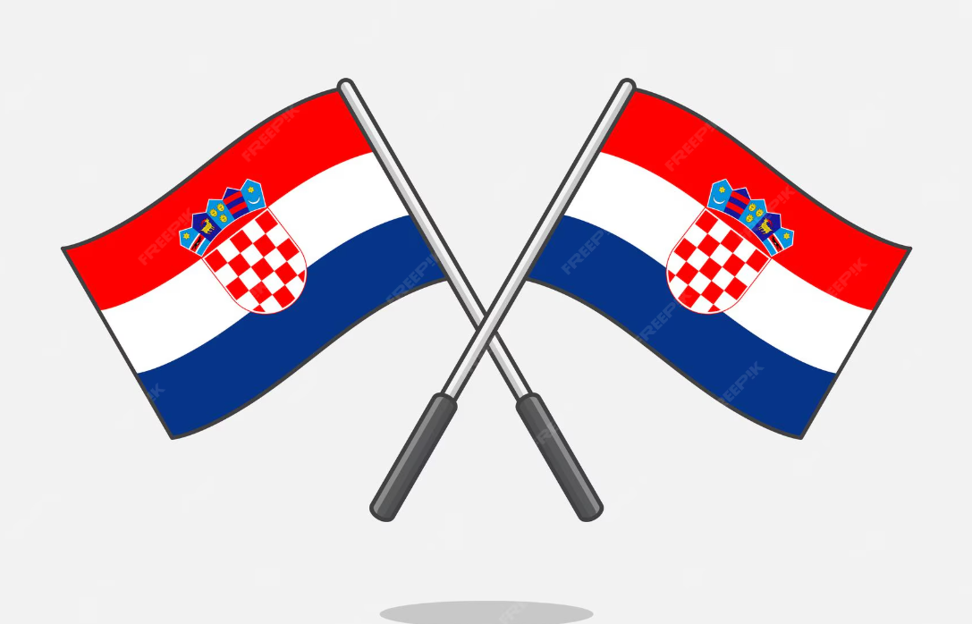

The Republic of Croatia recognizes that the rapid changes caused by China in the global balance of power require NATO to reshape its future policies and partnerships. China’s fast growing military capabilities, efforts regarding economical pressure and ongoing research aiming for technological superiority, constitute a systematic threat to the Alliance’s core security principles and the rules based international regularity. As a Mediterranean nation, Croatia strongly supports for a comprehensive and resource balanced strategy that responds to this threat without weakening NATO’s internal cohesion or its deterrence efforts against Russia. China’s influence is no longer a matter of geography, but a principled issue including security, technology and economics.
Developing a strategic response to China tests NATO’s internal unity. It is vital to manage the differences among Allies who seek to balance China’s economic opportunities with associated security risks. In addition, NATO’s limited resources must be distributed fairly and sustainably between the reinforcement of the Southeastern Europe against Russia’s ongoing aggression and measures aimed at countering China’s global influence. Croatia emphasizes that the Alliance must not compromise its core mission of collective defense. China’s relentless pursuit of technological supremacy in artificial intelligence, 5G, and quantum technologies impaires the West’s technological advantage and increases security vulnerabilities. Croatia is deeply concerned that foreign investments in critical infrastructure in the Adriatic and Southeastern Europe such as ports and telecommunications may lay the groundwork for future Chinese military or economic pressure. The most coherent response to China’s global influence lies in a cooperation framework that goes beyond geography. Engagement with key Indo-Pacific partners Japan, South Korea, Australia, and New Zealand should not remain limited to consultations but should include concrete operational cooperation.
Croatia believes it is essential for NATO to adapt to the geopolitical realities of the 21st century. China’s rise requires a strong and coordinated response that preserves Alliance cohesion, balances resources wisely, and expands NATO’s global vision toward the Indo Pacific. Croatia remains committed to contributing actively to this historic adaptation while safeguarding NATO’s core mission of collective defense.

