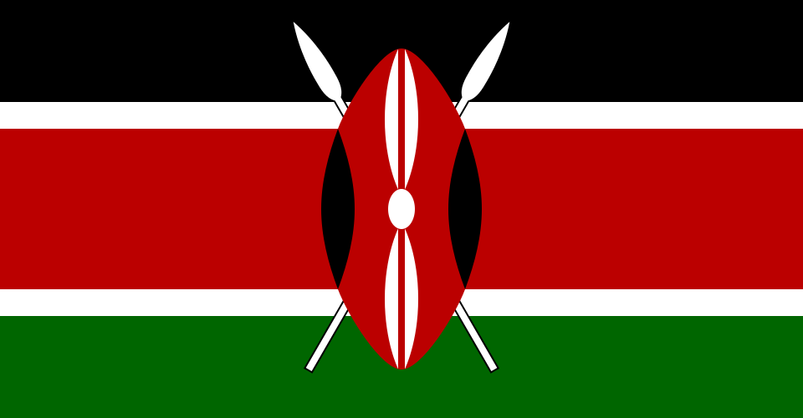
Country: Kenya
Committee: The Special Political and Decolonization Committee (SPECPOL)
Agenda Item: Reassessing the Political Status of Disputed and Non Self Governing Territories

Kenya is a country that takes the issue of decolonization and self determination due to its historical background. Having gained independence from colonial rule in 1963, Kenya believes that this process is still globally incomplete and that some peoples have not yet fully achieved the right to determine their political future. So, Kenya views the Non-Self-Governing-Territories agenda, conducted within the United Nations framework, not only as a matter of the past, but as an issue linked directly to the peace, justice an stability today. Kenya considers the principle of self-determination, enshrined in the UN Charter, a fundamental principle and supports the role of Special Political and Decolonization committee (SPECPOL) in protecting this right.

Kenya views long-standing unresolved issues like Western Sahara as a result of an incomplete decolonization process. In statements made at the United Nations General Assembly and the Fourth Committee sessions, Kenya emphasizes that such problems should be addressed within the work of international law and under the name of the United Nation rather than through unilateral actions. According to Kenya, the solution should be a peaceful, just an lasting process that respects the will of the peoples involved. It also considers the involvement of the African Union and supports strengthening cooperation between the United Nations and regional organizations. This approach demonstrates Kenya’s commitment to both upholding principles and maintaining regional stability

Study Guide of SPECPOL – YCMUN’25
United Nations General Assembly. (1960). Declaration on the granting of independence to colonial countries and peoples (Resolution 1514 (XV)). United Nations.
https://www.un.org/en/decolonization/declaration.shtml
United Nations General Assembly. (n.d.). Statements by delegations to the Special Political and Decolonization Committee (Fourth Committee). United Nations eStatements Portal.
https://estatements.un.org
United Nations. (n.d.). Special Political and Decolonization Committee (Fourth Committee). United Nations Department of Political and Peacebuilding Affairs.
https://www.un.org/dppa/decolonization/en/fourth-committee
United Nations. (n.d.). Non-self-governing territories. United Nations.
https://www.un.org/dppa/decolonization/en/non-self-governing-territories
United Nations. (n.d.). Reports of the Secretary-General and meeting records on decolonization. United Nations Digital Library.
https://digitallibrary.un.org

