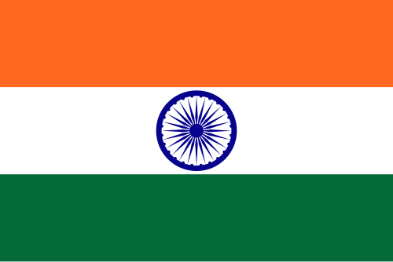

Committee: UNWOMEN
Country: Republic Of India
Agenda Item: Gender-based Inequalities in Global Health Systems
Delegate: Zeynep Öykü İş

India, officially the Republic of India, is a country in South Asia. It is the seventh-largest country by area; the most populous country since 2023; and, since its independence in 1947, the world's most populous democracy. Bounded by the Indian Ocean on the south, the Arabian Sea on the southwest, and the Bay of Bengal on the southeast, it shares land borders with Pakistan to the west; China, Nepal, and Bhutan to the north; and Bangladesh and Myanmar to the east. In the Indian Ocean, India is near Sri Lanka and the Maldives; its Andaman and Nicobar Islands share a maritime border with Myanmar, Thailand, and Indonesia.

India recognizes that gender-based inequality in global health systems is driven largely by social bias rather than biological differences. Historically male-focused medical research has led to the misdiagnosis and dismissal of women’s symptoms, while rigid gender norms often discourage men from seeking preventive and mental healthcare, resulting in delayed treatment. As a country with a large and diverse population, India acknowledges these challenges and emphasizes the need for inclusive, evidence-based health systems. India supports closing gender gaps in medical research, improving equal access to healthcare services, and strengthening global cooperation to reform health systems in a way that ensures fairness, dignity, and effective care for all genders.

In conclusion, India believes that gender-based inequality in global health systems must be addressed as a priority for sustainable development all across nations. Ensuring inclusive medical research, equal access to healthcare, and gender-sensitive health policies is essential to improving global health outcomes. India emphasizes the importance of strong international cooperation and UN-led initiatives to support countries with limited resources. Through shared responsibility and collective action, global health systems can be reformed to serve all genders with equity and dignity.

BIBLIOGRAPHY

https://en.wikipedia.org/wiki/India
https://en.wikipedia.org/wiki/Healthcare_in_India
https://www.ibef.org/industry/healthcare-india
https://en.wikipedia.org/wiki/Women%27s_health_in_India
https://womeningh.org/chapters/india/

