Committee: UNWOMEN 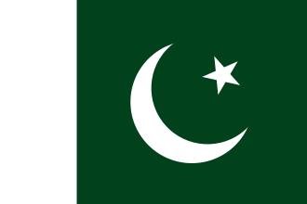

Country: Islamic Republic of Pakistan

Agenda Item: Strengthening protections around women’s fundamental rights in the MENA

Pakistan, officially the Islamic Republic of Pakistan, is a country in South Asia. It is the fifth-most populous country, with a population of over 241.5 million,having the second-largest Muslim population as of 2023. Islamabad is the nation's capital, while Karachi is its largest city and financial centre. Pakistan is the 33rd-largest country by area. Bounded by the Arabian Sea on the south, the Gulf of Oman on the southwest, and the Sir Creek on the southeast, it shares land borders with India to the east; Afghanistan to the west; Iran to the southwest; and China to the northeast. It shares a maritime border with Oman in the Gulf of Oman, and is separated from Tajikistan in the northwest by Afghanistan's narrow Wakhan Corridor.
The Islamic Republic of Pakistan strongly believes in protecting and empowering women through both national efforts and international cooperation. Pakistan has worked on the Convention on the Elimination of All Forms of Discrimination against Women and continues to work toward its goals by improving laws and institutions within the country. In recent years, Pakistan has taken clear legal steps to protect women from violence, including laws against honor killings, workplace harassment, acid attacks, and domestic abuse.
In education, Pakistan has made fair progress by increasing the number of girls in primary and secondary schools. This has been supported through national education plans and scholarship programs, especially for girls living in rural and underdeveloped areas. The government also recognizes that women’s health is essential for long-term development for their rights as healthy citizents. As a result, Pakistan has expanded maternal and reproductive health services through community-based programs that provide prenatal care, vaccinations, and trained medical support during childbirth.At the same time, Pakistan believes that meaningful progress must come from within each country. Long-lasting reform cannot be achieved through alone, but through cooperation, capacity-building, and respect for cultural and social structures.
Pakistan calls upon this committee to collaborative solutions, technical assistance, and development-based support that empower women.

Bibliography
https://en.wikipedia.org/wiki/Women_in_Pakistan
https://en.wikipedia.org/wiki/Pakistan
https://www.pakistan.gov.pk/
https://pakistan.unwomen.org/en

