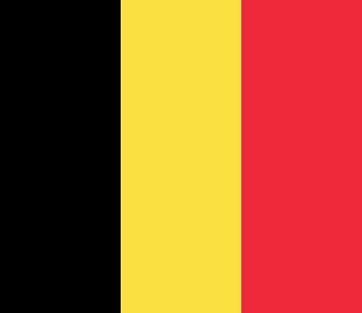
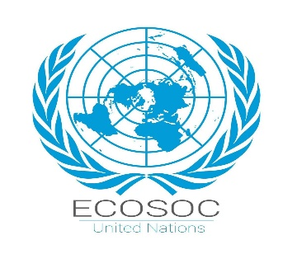
Country: Kingdom of Belgium
Committee: ECOSOC
Agenda: Youth Unemployment and Sustainable Economic Growth
Delegate: Berrak KARACA

The Kingdom of Belgium is a federal monarchy situated in Western Europe, bounded by France, the Netherlands, Germany, and Luxembourg. With an area of approximately 30,500 square kilometers, Belgium has a population of approximately 11.8 million inhabitants. The country is situated between the Latin and Germanic parts of Europe and has three official languages: Dutch, French, and German. Having become independent from the Netherlands in 1830, Belgium was occupied during both World Wars but rebuilt itself into one of the most stable democracies in Western Europe. It is currently a founding member of both the European Union and NATO, actively participating in international cooperation and economic development.
Belgium has an advanced, high-income, market economy with significant service components. With a per-capita GDP of 47,400 euros in 2022, it stands about 33% above the EU average. The service sector accounts for 74% of the economy, industry 23.9%, and agriculture 2%. In 2023, over 5.3 million active persons could be found in the labor market. The general employment rate reached 66.6%, which is 3.8 points lower compared to the EU27 average but 2.1 points higher than in 2018. For men, the employment rate was 69.9%, for women 63.3%, and for youth 26.5% — all below the EU average. These figures are an indication that one of the main challenges to sustainable growth is integrating young people into the labor market.
The Government of Belgium focuses on improving the alignment between education and employment, offering enhanced opportunities to young workers. Policies include promoting vocational and digital skills programs, encouraging entrepreneurship and innovation, and promoting conditions for fairness and inclusivity in the labor market. Further, the country invests in the green and digital economy to create new and sustainable job sectors. Since the unemployment benefit system in Belgium is limited, it supports active labor market programs to strengthen long-term employment and productivity.
Belgium balances environmental sustainability and energy security in its energy policy. While the 2003 law planned to close all reactors by 2025, recent energy crises extended some of their operations. Still, it continues to invest in renewable energy in a bid to cut carbon emissions and ensure a stable energy supply.

In this regard, Belgium attaches central importance to youth employment within ECOSOC for the better realization of sustainable and inclusive economic growth. The country calls for increasing access to education and training for young people, encouraging entrepreneurship among them, promoting gender equality in the labor market, and investment in green and digital transformation. It is committed to working with all members of ECOSOC in sharing best practices, developing competence programs, and creating equitable opportunities for youth in all countries. Nevertheless, Belgium is also fully committed to the building of a social justice economy, eco-friendly and innovative. For Belgium, the key to global stability and prosperity in the long term lies in investing in young people through education, opportunity, and participation.
Resources:
https://eures-europa-eu.translate.goog/living-and-working/labour-market-information/labour-market-information-belgium_en?_x_tr_sl=en&_x_tr_tl=tr&_x_tr_hl=tr&_x_tr_pto=tc
https://delegatepal.com/
http://www.bbc.com/news/world-europe-17209277
https://www.imuna.org/resources/country-profiles/belgium/
https://www.aa.com.tr/tr/dunya/belcika-ilk-kez-bir-nukleer-reaktor-kapatiyor/2693053

