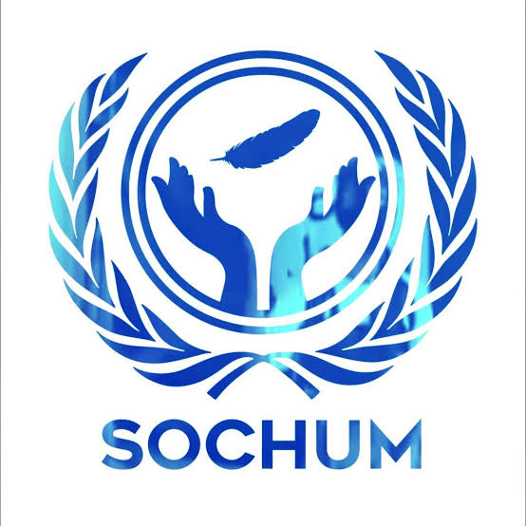
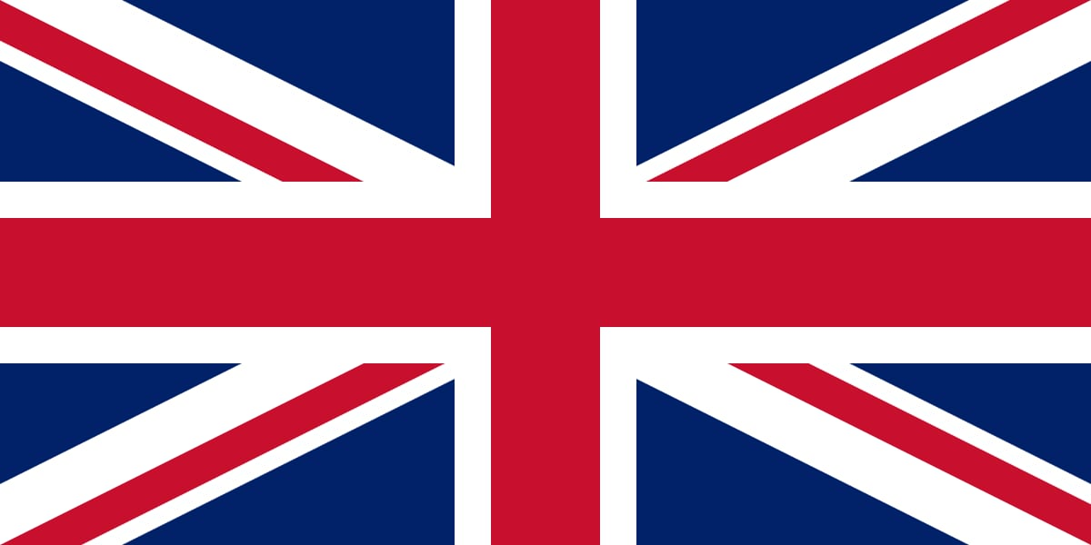

Position Paper - United Kingdom(UK)

Country : United Kingdom

Committee : SOCHUM

Topic : Ensuring the rights of indigenous peoples in the context of climate change and environmental degradation.

Agenda Items :Social Development, Advancement of Women, Protection of Vulnerable Groups, Promotion of Fundamental Freedoms, Human Rights promotion and protection.

Delegate :Mustafa Oğuzhan Çelik

The United Kingdom is an island country located in Western Europe. The country's surface area is 243,610 km² and its population is around 65 million. (According to July 2016 data) The United Kingdom is a UN, NATO and former EU member that cares about human rights and supports the protection of human rights. Freedom of expression comes to the fore with social equality, women's rights and LGBT+ rights, but the United Kingdom is a pragmatic state that pays attention to protecting its own interests while protecting human rights.

According to the United Kingdom, climate change is an important environmental problem that can change the balance of the world and will deeply affect people's lives, especially indigenous people, by harming the environment and nature; it is impossible not to take it seriously. It is quite reasonable for the United Kingdom to think like this because it is affected by so many situations such as soil inefficiency from climate change, temperature changes, unemployment in agriculture as a result of irregular rains, damage to the environment where local people live and, accordingly, their socio-cultural life is negatively affected and these lead to violations of rights. Although the UK is a state that causes a lot of damage to nature, it implements policies to reduce the damage day by day because it is aware that climate change negatively affects the rights of its people, especially its indigenous people.
In this process, the UK has worked on climate and human rights. For example:
*It signed the United Nations Declaration on the Rights of Indigenous Peoples(UNDRIP).
*It introduced the "Climate Change Act" to reduce environmental pollution.
*It has supported and continues to support projects that contribute to the defense of women and vulnerable groups against the effects of climate change.
*It also provides funding services to countries and communities that carry out work under the "Green Climate Fund".

The UK believes that all individuals should live freely, equally, safely. That's why the UK recommends these to protect local people who are most affected by climate change:
*Listening to local people's ideas and speaking up for them at UN meetings.
*Supporting indigenous women to take on roles and even become leaders in their communities.
*Helping indigenous communities by providing them with sufficient funds and meeting their needs.
*Collaborating with other countries and organizations to reduce environmental damage.
*To introduce new laws that protect nature, culture and human rights.

References:
1. United Nations. (2007). United Nations Declaration on the Rights of Indigenous Peoples (UNDRIP).
2. United Kingdom Government. (2008). Climate Change Act.
3. Green Climate Fund. (n.d.). About GCF and Indigenous Peoples Projects. Retrieved from https://www.greenclimate.fund
4. United Nations Department of Economic and Social Affairs (UN DESA). (2024). Indigenous Peoples and Climate Change.
5. UK Foreign, Commonwealth & Development Office (FCDO). (2023). Human Rights and Equality Policy Papers
6. www.delegatepal.com

