Country:İndonesia. 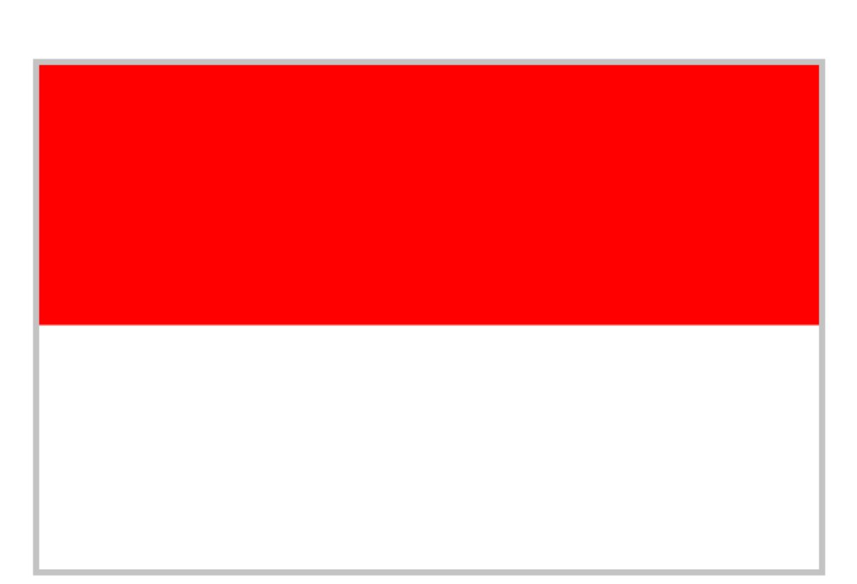
Committee:SOCHUM
Agenda İtem: Ensuring the Rights of İndigenous People in the Context of Climate Change and Environmental Degradation

Indonesia is home to more than 50 million indigenous people. Its total population is approximately 280 million. It is the world's fourth most populous country. It also has the largest economy in Southeast Asia. Its economy is based on agriculture, mining, and industry.
Clime change, rising sea levels, forest fires, and dry are harming their lives, cultures, and lands. That's why the government invests in renewable energy and the digital economy.
Indonesia believes that protecting the rights of indigenous peoples is necessary to continuing both environmental balance and social harmony.

The government recognized indigenous forest rights through a 2013 Constitutional Court decision and has committed to reducing greenhouse gas emissions under the Paris contract Indonesia also continues to protect the environment and improve clime conditions through reforestation and other sustainability projects.

Indonesia believes that the international community must take stronger action to support indigenous rights. Countries should work together to provide financial assistance and organize educational programs that help indigenous communities take an active role in fighting climate change. Indonesia remains committed to building a fair and sustainable future for all.

