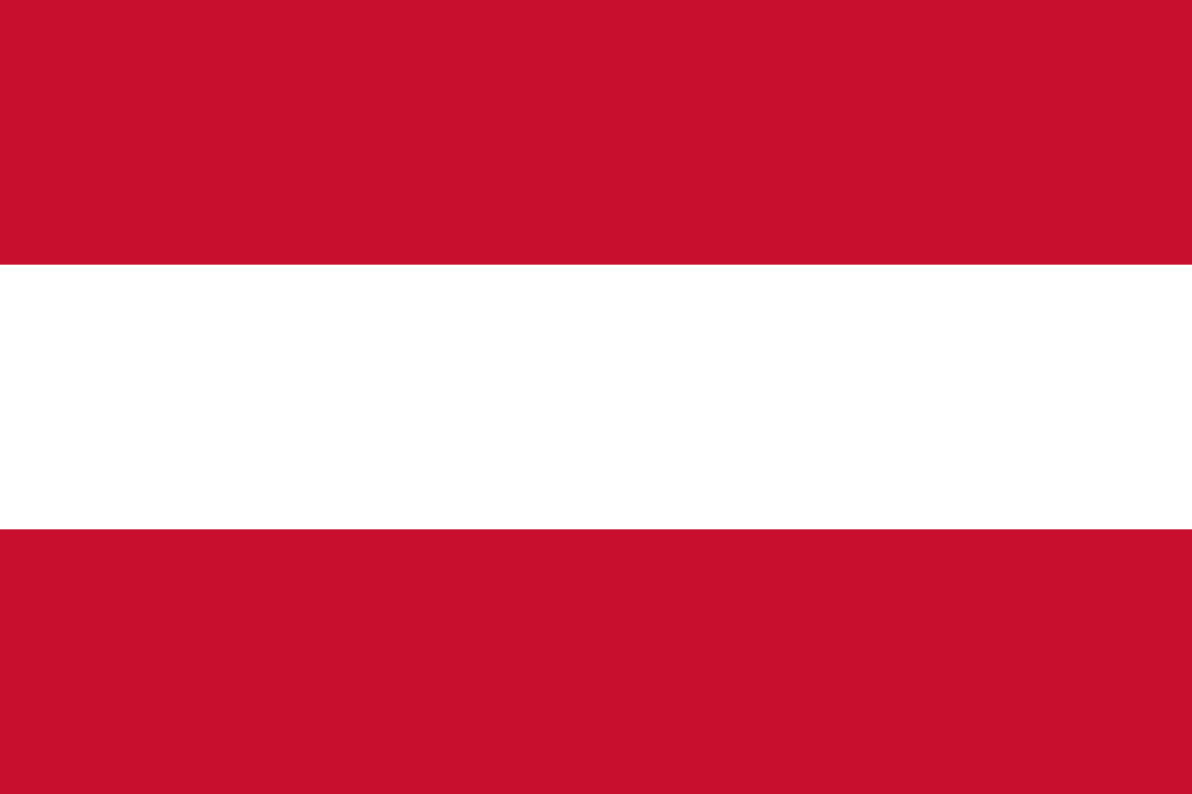
Delegation of Austria
Committee: SOCHUM
Agenda Item: Ensuring the Rights of Indigenous Peoples in the Context of Climate Change and Environmental Degradation

The Republic of Austria recognizes that due to climate change and environmental degradation, the life, culture, and dignity of Indigenous peoples worldwide face serious threats. Austria is a strong supporter of international efforts to promote and protect the rights of Indigenous peoples, even though there are no Indigenous inhabitants in Austria. As Austria sees it, in these matters, Indigenous peoples play an important role in protecting the environment; their traditional knowledge is important for the resilience of the global climate.
Austria has, through its engagement in various UN agencies such as the Human Rights Council, UNDP, and UNEP, supported human rights and climate action. It has made various contributions to global climate funds and voted in favor of several resolutions concerning Indigenous peoples' rights within the UN. Austria has also financed projects through its development cooperation that help indigenous peoples strengthen environmental protection and adapt to the consequences of climate change.
The UNDRIP calls on all Member States to ensure that the rights to land, culture, self-determination, and involvement in decision-making are protected; Austria fully supports this. Austria further invites collaboration, in regard to the integration of Indigenous issues into frameworks on climate policy, with the Human Rights Council, UNDP, UNEP, and any other relevant body. The delegation underlines that it is of high importance to involve Indigenous peoples in the elaboration and implementation of climate solutions, including those affecting their ancestral lands and livelihoods.
Austria advocates for the protection of environmental defenders and Indigenous activists, who are often threatened because of their struggle to protect their lands, as well as increasing financing for adaptation and mitigation programs that directly involve Indigenous communities in order to advance global action. Austria believes that this can be further helped by enhancing international financial structures, strengthening early-warning systems, and encouraging sustainable land management to enable Indigenous peoples to protect their traditional heritage and adapt to climate concerns. The country remains committed to multilateralism and ready to work with all Member States to ensure that climate action respects human rights and protects the voices of Indigenous peoples globally.

