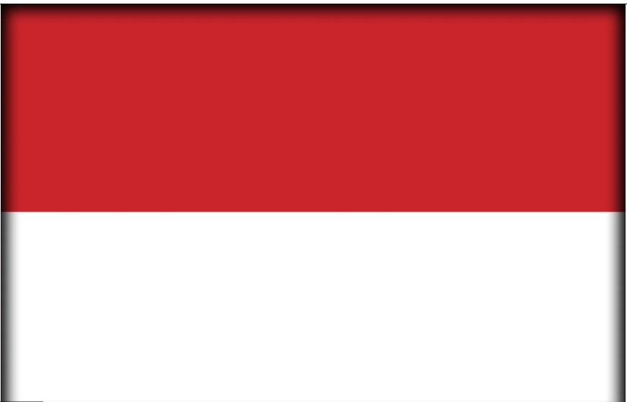
Country: Republic of Indonesia
Committee: The United Nations Programme for Gender Equality and the Empowerment of Women (UNWOMEN)
Agenda Item: Strengthening Protections Around Women’s Fundamental Rights In The MENA Region
School: Bahçelievler Deneme Anatolian High School

Our country is Republic of Indonesia which is located Southeast Asia and Oceania, between the Indian and Pacific oceans. Comprising over 17,000 islands. Our country has huge areas of wilderness that support one of the world's highest levels of biodiversity. We share land borders with Papua New Guinea, Timor-Leste, and East Malaysia, as well as maritime borders with Australia, Singapore, Vietnam and others. By the 7th century, we had become a crossroad for international trade. Our country announced its independence on 17 August 1945. Our society contains hundreds of ethnic and linguistic groups. Our country is a presidential republic. Jakarta is our most popular city and former capital but on August 17, 2024, the capital was officially moved to Nusantara.
Our country has a complex relationship with women’s rights that is affected by culture, religion, and law. In recent years, our country has changed in a good way such as education and employment. Recently, many women attend university, work in different professions, and take part in politics. For example, we have had female ministers and women are more visible in public life than in the past.
However, women in our country still face some problems. In particular areas, traditional roles expect women to focus only on family life, which limits their freedom. Issues like early marriage and domestic violence still exist. Even though there are laws to protect women, they are not always followed in every part of the country.
In addition, one possible solution is improving education about gender equality. Schools can teach both boys and girls about equal rights and respect from a young age. Another solution is stronger law enforcement. Although laws already exist to protect women, the government should make sure these laws are applied equally in all regions. This would help reduce problems such as domestic violence and early marriage.
Overall, women’s rights in our country are improving, but change happens slowly. While our government and our social organizations are working to support gender equality. For real equality, both legal reforms and social awareness are necessary.

Elif ÜNAL
Delegate of Indonesia

Bibliography:

- United Nations Women (UN Women). Gender Equality and Social Development in Indonesia. United Nations.
- United Nations Development Programme (UNDP). Human Development and Social Cohesion in Indonesia. UNDP Indonesia.
- Organisation of Islamic Cooperation (OIC). Islamic Values and Social Protection in Muslim-Majority States. OIC Publications.
- World Bank Group. Women, Poverty, and Development in Indonesia. World Bank.

