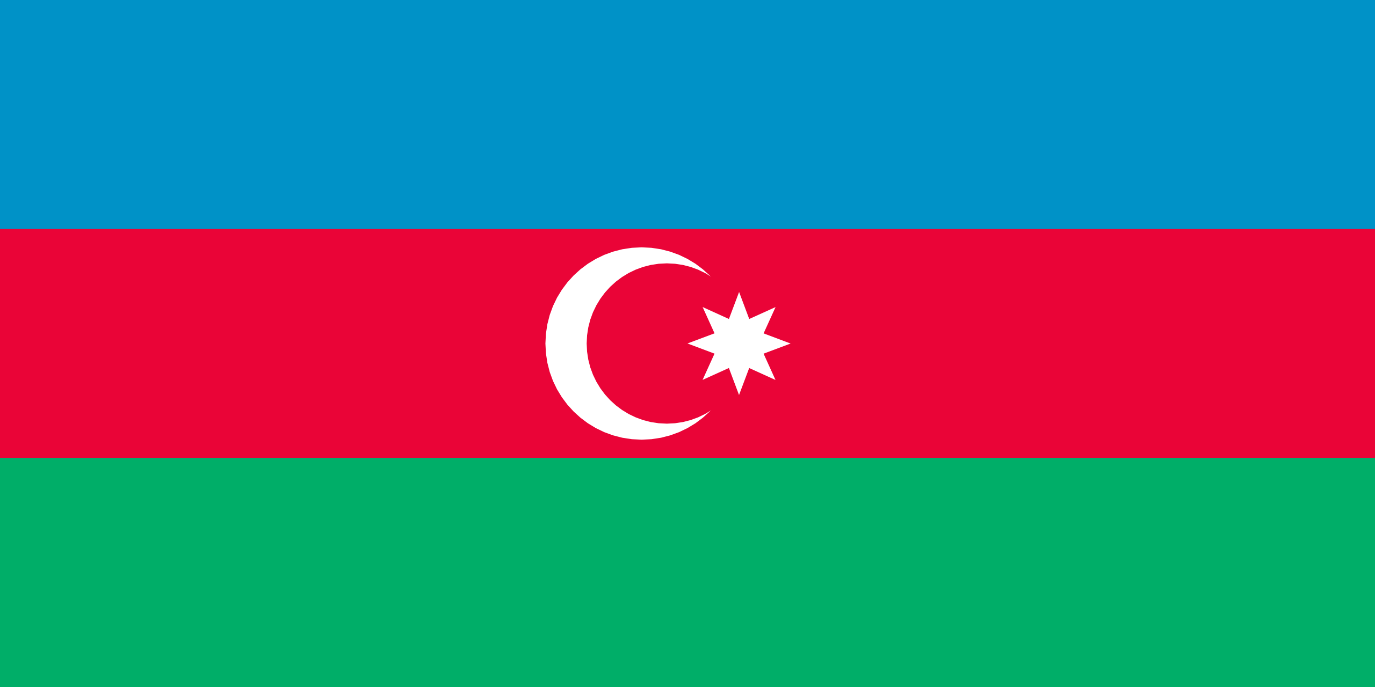

Conference: Ted University Mun Training and Development Conference 2021
Committee: Dısarmement and International Security Committee ( DISEC )
Topic: The Issue of Afghanistan
Country: Azerbaijan
Delegate: Emine YAMAN

Azerbaijan, officially the Republic of Azerbaijan, is a country located in the Caucasus, the intersection of Western Asia and Eastern Europe. On the border of Caspian Sea. It is located between Russian and İran. Azerbaijan, which was founded 113 years ago, joined the Soviet Union 111 years ago. It gained full independence in 1991. Social welfare, security, full independence and borders have an important place in Azerbaijani politics. Azerbaijan, which entered many wars in the name of secession in the Nagorno-Karabakh Republic, later came under the rule of Azerbaijan after the conflict that took place in 2020.

The Afghanistan problem is a world problem that has been going on since history. Due to the inability to suppress some problems that were prevented by the suppression of the uprisings that occurred from time to time, the Taliban became the head of the official administration of Afghanistan. When the Taliban came to power, the people began to have many difficulties. One of the biggest problems in society is security vulnerabilities. We think that if the Taliban administration does not unite with its people, the people will leave the country and an excessive wave of refugees will occur. We believe that it is very important to impose strict sanctions on the people, to solve security gaps, refugee problems as soon as possible and to ensure the welfare of the people under the Taliban administration. The wars in the Taliban, which aim to reduce its foreign dependency in disarmament, create difficulties and obstacles to this situation.

In this world we live in, we think that it will be important for the welfare of the society that women, children and all people have the right to security and live in peace. We hope that this problem in Afghanistan will end and world peace will be established.

