
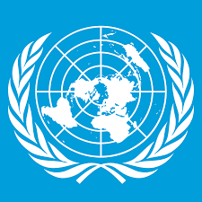

Comittee: North Atlantic Treaty Organization(NATO)
Agenda Item: Addressing he Strategic Implications of China’s Expanding Global Influence
Country: Republic of Hungary
Delegate: Berrin Betül Özer

Republic of Hungary is honored to be part of this meeting. Hungary considers that China’s expanding global influence is one of the most defining strategic challenges of the 21st century. A NATO member since 1999, we are follows an independent and pragmatic foreign policy that attaches importance to establishing balanced relations with both the West and East.
Economically, Hungary views China as an important country for global connections. We argue that economic strength should be achieved through diversification, not by breaking away from China. We also believe that NATO’s primary focus should stay on the Euro-Atlantic region.
In conclusion, Hungary believes that the stability of the international order can only be achieved through pragmatic cooperation, respect for sovereignty, and the pursuit of common well being

