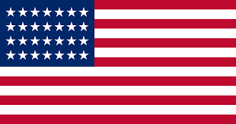
Country: United States of America
Committee: WHO (World Health Organization)
Topic: New Normal After the COVID-19 Pandemic
and the Role of Vaccination
It’s an undeniable honor to be able to represent the United States of America at such an amazing conference. The United States of America is one of the biggest countries and has a population of around 329.5 million. It has borders with Canada and Mexico.
Coronavirus also as known as Covid-19 has been in the United States of America since January 13, 2020. Which made us have hard times, deaths, and other problems since it started. After our big efforts, we can live our new normal. The new normal for us is we still need to take caution but we’re thinking about having relaxed life.
We think that vaccination is the only thing that can make us turn back to normal. In our country, everyone older than five years old can take all types of vaccines. Also, everyone older than twelve can take three doses of the vaccine. Most of the states in our country require wearing masks indoors 36 states that at some point in the pandemic had orders broadly requiring residents to wear masks in public have lifted them and some of the states have moved via legislation or executive action to prevent local governments and school districts from doing so.
So our main point is everyone needs to take their caution for Covid-19 and needs to wear masks for a healthy life and provide having pandemic.
At this conference, we are looking forward to finding solutions for vaccines and pandemic situations for the countries that can’t ensure. We are also hoping to have fruitful debates.

