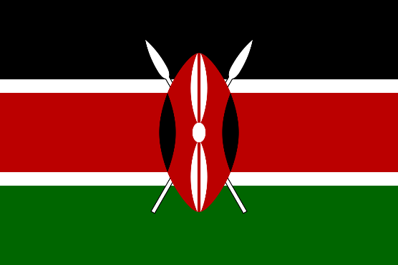
Commitee: United Nations Economic and Social Council (ECOSOC)
Country: The Republic of Kenya
Agenda Item: Tackling Youth Unemployment and Promoting Sustainable Economic Growth
Kenya is strategically located in East Africa, sharing borders with Tanzania, Uganda, Ethiopia, Somalia, and South Sudan. Kenya comprises fourthy seven administrative counties. Each county has its own culture and geography. Nairobi serves as Kenya’s administrative and political center. The city was founded in 1899 and became the capital of Kenya in 1907, replacing Mombasa. Kenya has a coastline in the Indian Ocean. The country is home to a rich mosaic of cultural and touristic regions. It is home to Mount Kenya, the second-highest peak in Africa, which symbolizes the country’s rich natural heritage and offers significant potential for eco-tourism and sustainable development. Kenya is home to over 43 languages and dialects, reflecting its rich ethnic diversity and cultural heritage. English and Swahili serve as the official languages. English is primarily used in government, legal affairs, and formal education. Swahili functions as a unifying national language, widely spoken across ethnic groups and used in everyday interactions. As of 2025, Kenya’s population is estimated at approximately 53 million, with a significant proportion under the age of 25. The country’s median age is just 20, reflecting a vibrant and youthful demographic. This presents both opportunities and challenges in areas such as education, employment, and innovation. Kenya’s government continues to prioritize youth empowerment through inclusive policies, vocational training, and digital literacy initiatives, aiming to harness the full potential of its young population for sustainable development. Kenya is a republic with a presidential system. The President is both the Head of State and Government, elected directly by the people. The country has a two-chamber Parliament and follows a democratic constitution.

Youth unemployment is a serious challenge to global stability and inclusive development, particularly in regions with rapidly growing populations. As millions of young people struggle to access decent work, the issue demands coordinated, innovative, and sustainable policy responses. Sustainable economic growth is a long-term economic development that meets present needs without compromising the ability of future generations to meet their own. It balances productivity, environmental protection, and social inclusion by promoting responsible resource use, green innovation, and equitable access to opportunities.
People between the ages of 18 and 34 are considered youth. This is the group included in youth unemployment. Kenya's youth population makes up 21% of its population. 38% of Kenya's youth are unemployed. More than eight hundred thousand young people enter the workforce in Kenya each year, driving the youth unemployment rate higher each year. The Kenya Youth Employment and Opportunities Project (KYEOP) was launched with the aim of reversing the alarming level of youth unemployment that threatens the overall economic well-being of the country. The project is structured around four key pillars: enhancing youth employability, creating jobs, strengthening Labor Market Information Systems (LMIS), and improving youth policy development and project management.
Another project by Kenya to tackle youth unemployment is the Generation Kenya 2025–2029 Strategy. As part of the country’s long-term efforts to support young people, Kenya launched this initiative to help youth gain market-relevant skills, find jobs, and connect training with real employment. It focuses on fast-growing sectors such as technology, green energy, digital services, and manufacturing, where most participants are hired within 3 to 6 months after completing their training.
Kenya promotes sustainable economic growth by investing in green sectors, improving capital markets, and supporting inclusive development strategies aligned with Vision 2030. These efforts aim to balance productivity, environmental protection, and social equity.
Vision 2030 is Kenya’s long-term development plan. It aims to turn the country into a middle-income economy by 2030, improving quality of life and raising average income through sustainable and inclusive growth.
The Government of Kenya has undertaken targeted initiatives to address youth unemployment while simultaneously advancing sustainable economic development, reflecting its commitment to inclusive growth and long-term resilience

