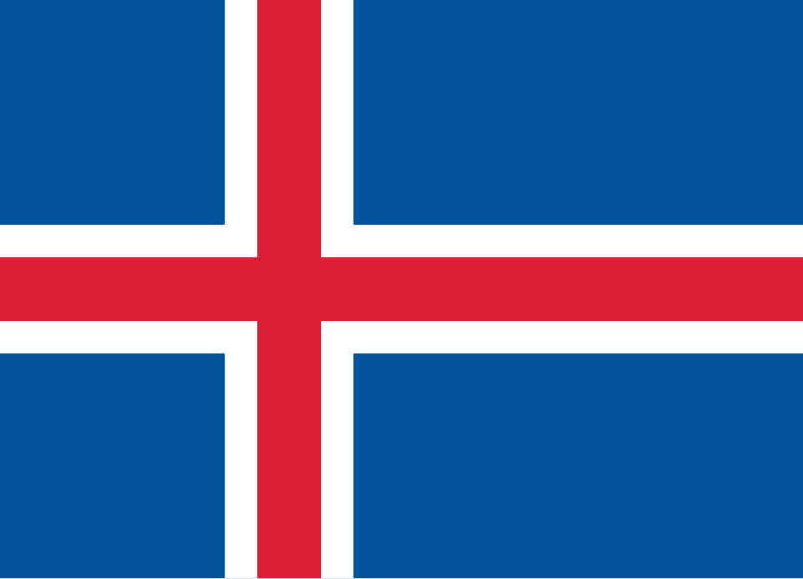
Country: Iceland
Committee: UNESCO
Agenda: Reducing Inequalities in Digital Education

Iceland is a small country located in Europe. It’s around 103.000km2. It is known for its name because the meaning of its name is the land of fire and ice. It has a population of 390.00. “It has a great GDP which is about 35 billion dolars”(Worldometers). “Their minimum salary is 3369 dolars”(Safeguard Global). Iceland has been a UN country for 75 years. Many people go there to see the Northern Lights and the volcanos, making Iceland a popular country.
Iceland has a very great education system, but there are some points that we need to improve. Firstly, using digital devices has some benefits for teaching and learning, but it also causes distractions. Restricting or limiting the use of technological devices such as smartphones can prevent distractions. Secondly, Iceland has high speed Internet but in some rural locations they don’t have the same speed. That causes inequality for students who live in rural areas. Although the government improved the Internet connection with Ísland Ljóstengt Project, rural locations still have limited connection. Also, immigrants and low income families should be supported more. Because of economic problems, some families cannot afford the same learning resources and some immigrants have difficulties with language.
As a solution to these problems, the Iceland government can help low income families by giving them extra subvention and should provide better internet connection to rural areas. Also, we need limits for using technological devices. Government can provide education to families and children on how to use technology beneficially. So, in conclusion, Iceland has a great education system but we need more development.
References:
- https://www.oecd.org/en/publications/oecd-economic-surveys-iceland-2025_890dbe05-en/full-report/raising-foundational-skills-and-education-quality_7c04602b.html OECD
- https://en.wikipedia.org/wiki/Internet_in_Iceland#:~:text=Iceland%20is%20among%20the%20top,net%20at%20297.5%20Mbit%2Fs. Wikipedia
- https://www.oecd.org/en/publications/oecd-economic-surveys-iceland-2025_890dbe05-en/full-report/raising-foundational-skills-and-education-quality_7c04602b.html OECD
- https://www.norden.org/en/information/facts-about-iceland Nordic Cooperation
- https://en.wikipedia.org/wiki/Education_in_Iceland#:~:text=The%20system%20of%20education%20in,for%20children%20aged%206%E2%80%9316. Wikipedia
- https://www.worldometers.info/gdp/iceland-gdp/#:~:text=Nominal%20(current)%20Gross%20Domestic%20Product,International%20Monetary%20Fund%20(IMF). Worldometers
- https://unric.org/en/75-years-since-sweden-and-iceland-joined-the-un/#:~:text=19%20November%201946%20Sweden%2C%20Iceland,for%20the%20past%2075%20years. United Nations
- https://www.safeguardglobal.com/country/iceland/payroll/ Safeguard Global

