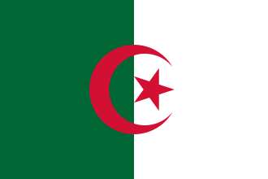
Country: Algeria
Committee: UNESCO
Agenda: Reducing Inequalities in Digital Education

Algeria’s official name is People’s Democratic Rebuplic Of Algeria. It’s located in nourth of Africa. Algeria’ s neighbors are Libya,Tunisa,Niger,Mali,Maurutina. Almost 47 million people live in Algeria. Arabs and Berbers represent the biggest part of the population.
In Algeria people do not have enough internet to learn something from internet in rural areas. This is very unlucky for them because you need to be online to learn new informations and for that case, you need digital items for education. The second digital education problem is, there is not enough people which know English very well. English is important in digital education because the coding language is English all over the world. “In Algeria English education starts in primary schools in 2022”(Anadolu Agenda) . This is inequal, in other countries they start earlier. And if we want a really a good digital education we need to raise professional teachers to create better education systems. Another problem is the rural areas, because in rural areas there is not enough internet connection and schools to teach digital education. And the second problem is economic problems. Some families don’t have enough income to send their childrend to schools.
For the first problem, the goverment needs more money to support to the rural areas, give technological school items like smart boards, tablets, laptops, etc. In addition to that, government can charge low income families to send their childrend to school. If the goverment does not have enough money, they can open a website and the people can support them from everywhere. Also government may ask help from international education organisations. They can make a group to support the schools the teachers and the students for a better education. This will be good for the rural areas and good for the Algerian people.Algerian teachers can make another group giving free digital education in schools or their homes. This group topic is rasing new teachers.

References;
https://www.aa.com.tr/tr/dunya/cezayir-de-ilk-defa-ilkokul-mufredatina-ingilizce-de-eklendi/2617652 Anadolu Agenda
https://africapolis.org/EN/country-report/Algeria Africa Polis
https://en.wikipedia.org/wiki/Algeria Wikipedia
https://akra.media/Haber/HaberDetay/76095/cezayir-de-14-milyon-insan-yoksul Akra media

