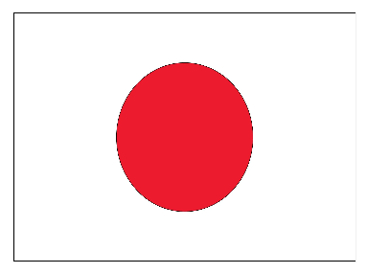
Protecting children from bullying and violence

Committee : UNICEF Country : Japan
Delegate : Aras Kara, Egebil Schools
Japan has a National Action Plan to end violence against children. This plan started in 2021. Many ministries and groups worked together for this plan. Civil society and children also shared their opinions. The main aim of this plan is to stop all types of violence against children. It also supports the Sustainable Development Goals, especially Target 16.2. The plan is checked every year. It will also be reviewed again after about three years. Japan wants to see if the plan works well or not. For preventing child abuse, Japan gives support from pregnancy to child care years. Families get health checkups and home visits. There are child and family centers in cities. There are also places where parents and children can meet.

Japan also wants to find child abuse early. For this reason, there are 24-hour hotlines. People can call these lines when they see a problem. This helps children get support faster. Ending violence against children is an important global goal. Many countries agree on this issue. Japan supports this goal and wants to help other countries too. Japan shares its own practices and experiences. This way, other countries can also learn from Japan.

In schools, corporal punishment should not be allowed. Teachers should follow the rules and guidelines. These rules are checked regularly. In families, corporal punishment should also be prevented. Parents should learn what corporal punishment is and why it is harmful. Japan also reviews its laws about discipline in the family. Japan continues to support child victims. Children get help to recover from psychological trauma. Teachers and school staff receive training about bullying. Counseling systems in schools are improved. These actions help schools follow anti-bullying laws and policies better.

