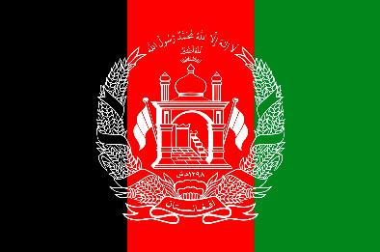
Ensuring access to education for refugee children

Committee: SOCHUM
Country: AFGHANISTAN
Delegate: SERRA SARAL, EGEBIL SCHOOLS
Afghanistan’s government provides fewer schools for girls than boys. Many children live far from a school so are not able to attend, which particularly affects girls. About 41 percent of schools have no buildings, and many lack boundary walls, water and toilets—disproportionately affecting girls. Girls are kept home due to gender norms that do notvalue or permit their education, or due to security concerns. A third of girls marry before age 18, and forces many girls out of school. The report calls on the Afghan government, and its international donors, to increase girls’ access to education through protecting schools and students, institutionalising and expanding models that help girls study, and taking concrete steps to meet the government’s obligation to provide universal free and compulsory primary education.
In some parts of the country, a shortage of schools and insufficient transportation are the main obstacles to education – a long walk to school means fewer children go. Geographical barriers, especially in mountainous areas, also make it hard for children to reach the classroom. Once children do make it, they often receive a lower quality of education because only 48 per cent of their teachers have the minimum academic qualifications (equivalent to an Associate Degree). The socio-political and humanitarian crises that Afghanistan faces critically affect a fragile education system. Natural disasters such as floods, earthquakes, and landslides exacerbate the situation for all children. These factors raise parental concerns about safety and can prevent them from sending their children to school.
Providing quality education for the most vulnerable. A strong education system is key to getting more children in school, keeping them there, and helping them to become healthy and responsible citizens. Working at the national, provincial, community levels in close collaboration with the Ministry of Education and other partners, our support focuses on the most vulnerable people in disadvantaged areas, particularly girls, to combat the lack of learning caused by poverty, discrimination and conflict. A girl’s education is not only a moral imperative but an economic necessity.

