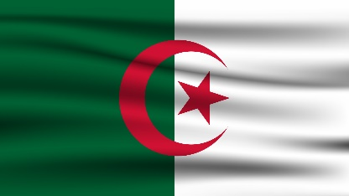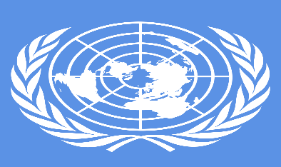
Adressing Health Issues Caused by Air Pollution
Committee: WHO
Country: Algeria
Delegate: Tuğçe Koçyiğit
Pollution in Algeria has become both a political and social concern. Garbage poses serious environmental and health risks. Despite the numerous environment-related laws and national plans that have been passed to preserve and protect the environment, pollution remains a major concern. This situation is burdening the public treasury, which allocates hundreds of billions of dinars annually to treat these diseases and their economic and social side effects. Pollution rates also continue to rise, which can be attributed mainly to toxic gases and smoke from factories, especially chemical ones, as well as CO2 emissions from vehicles. This is in addition to uncontrolled use of fertilizers and pesticides, which has increased air pollution and contamination of food for human consumption.
Ex‬cessive pollution can be detrime‬ntal to health‬ and there ‬‬‬‬‬are ‬even ‬forms ‬of ‬pollution, wh‬ich ‬can ‬render‬ ‬certain ‬areas normally ‬uninhabitable; this is a serious obstacle to socio-economic development. ‬Alg‬eria is ranked 42nd country in the world in terms of environmental ‬protection, out of 153 countries surveyed According to a st‬udy ‬‬‬‬‬‬‬‬‬‬‬‬‬‬‬‬‬conducted by ‬the ‬program of technical ‬assistance of ‬the ‬Mediterranean ‬environment (M‬ETAP), the degradati‬on of envir‬onment in Algeria ‬costing 1.7 billion $ per year, or 3.6 percent of GDP. Furthermore, in ‬Algeria, according to the national report on the state of environment it is ‬‬‬‬‬‬‬‬‬‬‬‬‬estimated that every ‬year 10‬ ‬to ‬12 million inhabit‬ants consult for‬ ‬acute ‬episodes of respiratory diseases. Moreover, 40% of infant mortality ‬(children ‬under‬ ‬1 ‬year) is‬ ‬caused ‬by ‬res‬piratory ‬diseases‬ ‬and ‬600000 ‬asthmatics suffer permanently Their direct costs are est‬imated at ‬‬‬‬‬‬‬‬‬‬‬‬‬‬‬‬‬‬‬‬‬‬‬‬‬‬15.000000 ‬USD ‬/ ‬year, ‬or 0.04% of ‬GDP. ‬It ‬can be ‬assumed that the number of these episodes is directly related to exposure to air poll‬uti‬on. ‬The present work aims to study the consequences of air pollution ‬on human health‬ an‬d the degradati‬on of environment in Algeria.‬‬‬‬‬‬‬‬‬‬‬‬‬‬‬‬‬‬‬‬‬‬‬‬‬‬‬‬‬‬‬‬‬‬‬‬‬‬‬‬‬‬‬‬‬‬‬‬‬‬‬‬‬‬‬‬‬‬‬‬‬‬‬‬‬‬‬‬‬‬‬‬‬‬‬‬‬‬‬‬‬‬‬‬‬‬‬‬‬‬‬‬‬‬‬‬‬‬‬‬‬‬‬‬‬‬‬‬‬‬‬‬‬‬‬‬‬‬‬‬‬‬‬‬‬‬‬‬‬‬‬‬‬‬‬‬‬‬‬‬‬‬‬‬‬‬‬‬‬‬‬‬‬‬‬‬‬‬‬‬
Some of the activities organized by the Ministry of Environment and Renewable Energy include the launch of national awareness campaigns to promote the cleanliness of neighbourhoods. These campaigns were supervised by the minister of environment and renewable energy in person on 30 October 2018, when the campaigns were launched with the participation of all the relevant departments as well as civil society organizations and associations. One of the mechanisms that aims to raise awareness is environmental education, mainly through cooperation between the National Education and Environment Ministries. This has culminated in the establishment of environmental clubs, the first 21 of which were inaugurated in schools in Alger Centre on 5 February 2019, with other municipalities expected to follow

