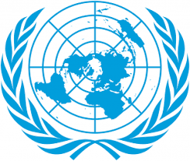
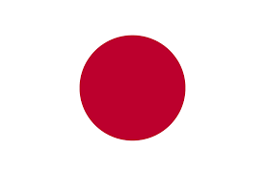
Country: THE STATE OF JAPAN
Committee: UNICEF (United Nations Children's Fund )
The name of the delegate: BERÇEM ARYA DOĞAN
Japan is an island country in East Asia. Located in the Pacific Ocean off the northeast coast of the Asian mainland, With a population of over 123 million as of 2025, it is the world's 11th most populous country. Tokyo is the country's capital and largest city.

The Japanese child allowance (Jidō Teate - 児童手当) is paid to those raising children aged 0 to 15 years. The benefits depend on the annual household income and, in addition to the child allowance provided by the government, some municipalities also have their own child allowance system. Our country didn’t only protect childs in our country but also suppert the children in uzbekistan
In terms of welfare, under the Child Welfare Law, the Japanese government is expanding child welfare facilities such as Child Guidance Centers, nursing homes, and daycare centers, increasing child protection and providing support to households.

We believe that if countries sign the United Nations Children's Fund (UNİCEF ), the rate of bullying will decrease.
If families were paid a fee to raise children like in our country, we would be able to instill a better sense of country awareness.

SOUCESS
https://en.wikipedia.org/wiki/Japan
https://www.japanlivingguide.com/expatinfo/socialsecurity/child-allowance/
https://www.unicef.org/uzbekistan/en/japanese-government-supports-child-prootection
https://www.mofa.go.jp/policy/human/child/initialreport/introduction.html

