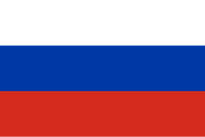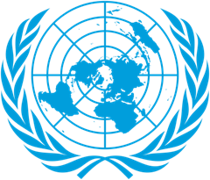

Country: RUSSIA FEDERATION
Committee: SPECPOL (Special Political and Decolonization Committee)
The name of the delegate: BEREN ERVA ÇAKIRER
As a Russian Federation, our country is the largest country in the world.146.1 million people (12.5% of the world’s population) live here. It is the ninth crowded country. Our country is governed by republic. Russian Federation is also one of the strongest countries.
When Russia starts colonialism somewhere ,Russia exploitation that country a long time because Russia don’t let anybody to revolt .Considering the colonial movements that began in the 16th century, Russian colonialism appears to have a different character from classical European colonialism. While Europeans chose distant lands as their colonial targets, Russians targeted the regions closest to their territorial borders. As one of the first steps of colonization, the Russians targeted cities that were considered strategically, geographically, and commercially important.
We think if countries get on well with each other, the number of the exploited countries will decrease. We think if countries get income except the way of colonization colonial target`s number will decrease.

SOURCES:
https://tr.wikipedia.org/wiki/Rusya
https://nek.istanbul.edu.tr/ekos/TEZ/50175.pdf

