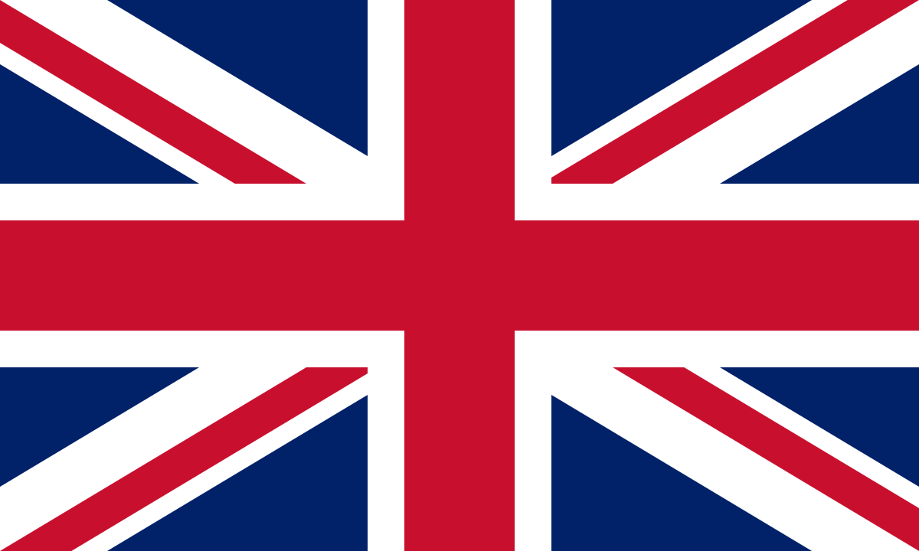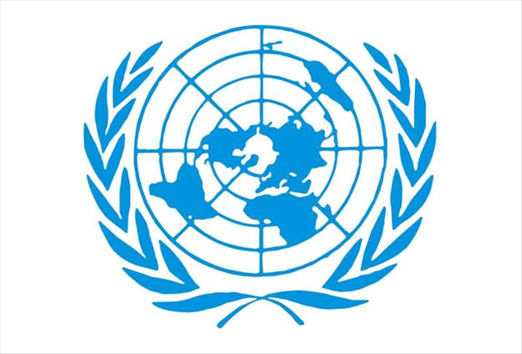
Country:The unıted kıngdom of great britain and nothern ıreland
Commıtee: ECOFIN
Topıc:(ECOFIN) Promoing the green economy and renewable energy ınvestments
The United Kingdom is an island nation comprising four countries: England, Scotland, Wales and Northern Ireland. It has been undertaking significant work in the field of renewable energy. We are focusing on our country's renewable energy policy through the work and investments it has made in recent years. We are making progress in areas such as wind and solar energy, and this progress is supporting us in terms of profit and the environment. The United Kingdom is undertaking a net-zero carbon project by 2050. So far, we are 30% behind this project, and we will accelerate our efforts to achieve it by 2050.
UK has increased its solar energy by 40% in the first quarter of 2025. The UK has seen an overall increase with 57,000 new rooftop panels,generating renewable energy. Wind and solar production increased more than noral in March. On March 30, it reached 72% more of the country's electricity demand.It surpassed its previous record in solar energy on March 18 with 12.2 GW and continued production Biomass has been above average both on a daily and monthly basis.
The UK produced approximately 3GW in February.It expanded its offshore capacity by commissioning its 0.9 GW Moray project.It has broken many production and share records in renewable sources in the last 16 years. According to the table of renewable energy, it shows a continuous increase on a monthly and annual basis.

https://www.greenpeace.org.uk/challenges/renewable-energy/
https://en.wikipedia.org/wiki/Renewable_energy_in_the_United_Kingdom
https://assets.publishing.service.gov.uk/media/68dbe477ef1c2f72bc1e4c4d/DUKES_2025_Chapters_1-7.pdf
https://reports.electricinsights.co.uk/wp-content/uploads/2025/05/WEL_Drax_EIQ_2025_Q1_Artwork.pdf

