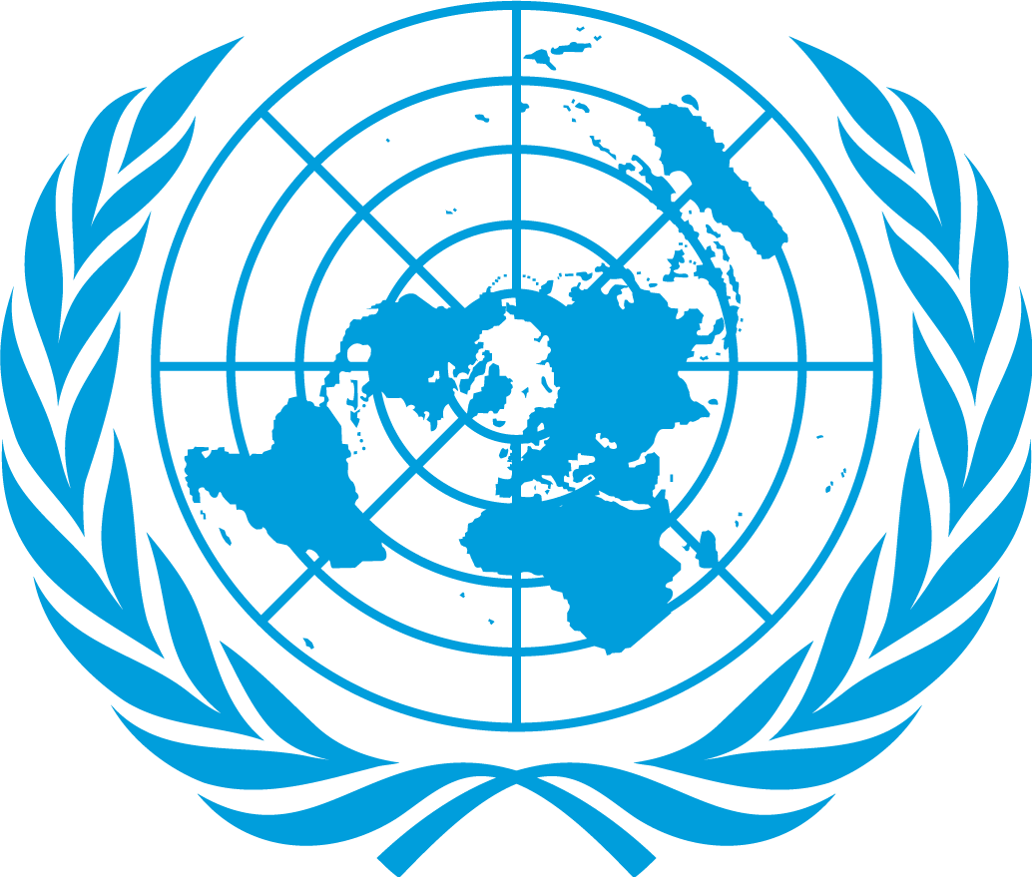

Committe: SOCHUM
Country: CANADA
Dalegate: ELİF ERVA BARAN
Canada considers refugee children's access to education a fundamental human right and implements inclusive policies accordingly. Canada is a country that highly values ​​people's vital and fundamental rights and always takes a humane approach when dealing with any legal applications related to refugees. Canada believes that those wishing to immigrate should have many options because the rights of every person are important to Canada. It is an active sponsor of women's rights, LGBTQ+ rights, and the prevention of gender-based violence. In line with its 'feminist foreign policy' principles, it funds human rights programs. Taking responsibility on the international stage, Canada provides financial contributions to global funds such as Education Cannot Wait to support children's access to education in conflict and crisis zones.
Refugee families with limited financial resources have been provided with support for school expenses, and scholarships have been made available for university-aged youth. This has largely prevented refugee students from dropping out of education. Through these practices, Canada aims not only to protect refugee children but also to integrate them into society. Canada also assumes responsibility at the international level and provides financial contributions to projects supporting access to education for children in crisis regions. This approach demonstrates that Canada views the education of refugee children not only as a national issue but also as a global human rights issue.
Canada recognizes that the refugee crisis cannot be resolved solely through the efforts of individual countries. Therefore, it actively collaborates with organizations such as the United Nations High Commissioner for Refugees (UNHCR), UNICEF, and the International Organization for Migration (IOM). Each year, Canada provides millions of dollars in humanitarian aid to these organizations, supporting not only refugees arriving in its own country but also civilians in crisis zones.
https://files.eric.ed.gov/fulltext/ED438941.pdf?
https://www2.gov.bc.ca/gov/content/education-training/k-12/administration/legislation-policy/public-schools/students-who-are-refugees?

