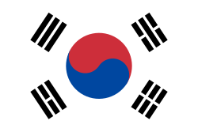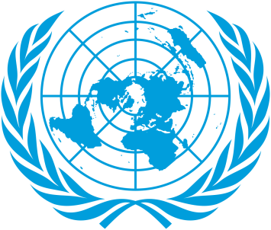
Committee: SOCHUM
Country: Republic of Korea
Delegate: Roza MAÇİN
Major Obstacles to Refugee Children's Access to Education
There are many significant barriers around the world that make it difficult for refugee children to access education. According to UNHCR, more than half of refugee children are unable to attend school are many significant barriers around the world that make it difficult for refugee children to access education. According to UNHCR, more than half of refugee children are unable to attend school. The main obstacles are: language barrier, financial inadequacies and economic difficulties, unsafe transportation and conflict environment, psychological amenities.
The Effects of Lack of Education on Refugee Children
Lack of education leads to deep and lasting problems in the lives of refugee children. Lack of education leads to deep and lasting problems in the lives of refugee children. Children who do not have access to education: they are becoming more vulnerable to the risk of child labor and exploitation, at risk of early marriage and human trafficking, are likely to be dragged into poverty because they lack reading and writing and basic skills, have difficulties in social cohesion, may experience psychological and emotional developmental disabilities, South Korea states that lack of education end,
South Korea's Proposals
Establishment of language education centers, Increasing safe and accessible school environments, Expanding digital and distance education opportunities, Integrating psychological support and trauma programs into education, Solving document and registration problems with flexible procedures, Scholarship programs and international educational partnerships
In the References'
UNHCR – "Refugee Education 2030”
2023. UNICEF -”Education in Emergencies in the References'
UNHCR – "Refugee Education 2030”
2023. UNICEF -”Edition in Emergencies"
2023. UNES Support

