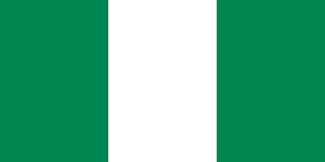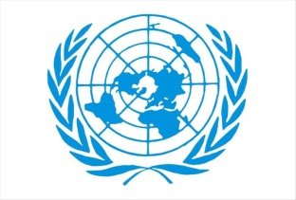

Promoting the Green Economy and Renewable
Country: the Federal Republic of Nigeria
Committee: UN Economic and Financial Committee
Delegate: Said KESKİN

Nigeria has a large forehead located on the African continent, and its livelihoods are usually peanuts, cotton, palm trees, cocoa and rubber. Nigeria is the sixth country in the World in Cocoa and rubber production. Nigeria has a very large population. Nigeria contains very old findings in terms of history Our Vice President Kashim Shettima announced that over $400 million in new investment commitments have been made in our country's renewable energy production chain. In his speech at the "2025 Nigeria Renewable Energy Innovation Forum" held in Abuja, Shettima noted that important investment decisions were made as a result of the collaborations and discussions held within the scope of the forum.
While several measures are necessary to implement our country's Climate Change Act 2021, the law demonstrates the seriousness with which we approach climate action. As our first standalone comprehensive climate change law in West Africa and one of only a handful of change advocacy and a legal basis for potential climate litigation in Nigeria. Such laws both globally and regionally, it has the potential to be a strategic tool for climate

Stating that Nigeria must take urgent steps to transition to a low-carbon economy, Shettima said that delay in combating climate change threatens our country's development goals and economic future. Shettima announced that the government has begun negotiations with global financial institutions to provide climate financing exceeding $60 million for pilot "green energy" centers, including a hybrid energy project to be implemented at a major airport.
SOURCE
https://yesilhaber.net/
https://www.wikipedia.org/

