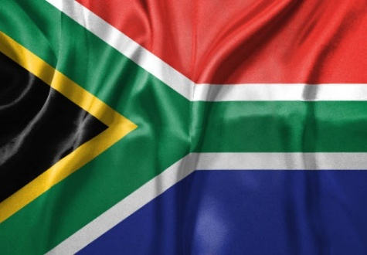
Country: South Africa
Agenda item: Reconstruction and Development in Post-Conflict
Regions
Committee: SPECPOL

South Africa is the county that has lived colonialism and racism for long years. European countries has wanted to conquer South Africa due to its rich mineral resources and strategic location. This situation has impacted to the lives of the local people negatively.

The Netherlands people came to South Africa and settled in the Cape Town region in 1652. After that, The British took over the administration of this country. These Colonist countries has forced local people to work to extract precious metals such as gold and diamonds and so they took their lands from their hands. In time, the white minority have became to rule the country. Black people and other local peoples has been deprived from many rights. People were separated based on their skin colors, unable to attend the same schools and people were not allowed to live in the same areas. This discriminatory system is called racism.

South African people has fought against these injustice for many years. In 1994, elections have been held in which everyone had equal voting right thanks to the efforts of Nelson Mandela and his friends. In this manner, racism had been ended. The process which South Africa is experiencing shows us how important equality, freedom and humans rights are.

In my opinion, unfortunately racism is still exist in some areas of South Africa. I hope this racism nonsense will be completely ended in our near future.

