
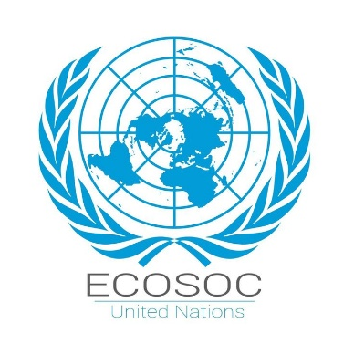
Committee: Economic and Social Council
Country: Pakistan
Agenda Item:Combating Youth Unemployment and Promoting Sustainable Economic Growth
Name: Kübra Nur Uzunçam
Youth unemployment has become one of the most serious challenges facing the global economy today. Global youth labor force participation rates are declining. The global youth unemployment rate is 13.1%. Millions of young people are trapped in temporary, part-time, or casual, atypical jobs that offer low returns and limited prospects for career advancement. Declining living standards and low productivity, combined with persistent inflation, create conditions that foster growing inequality and undermine efforts to achieve social justice. And without greater social justice, sustainable recovery will never be possible

Pakistan is a country in South Asia. With a population of over 241.49 million, it is the fifth most populous country in the world.Pakistan has an unemployment rate of 5.5%. Annual GDP growth is 3.2%. Pakistan is implementing active policies to combat youth unemployment. Young people constitute 26% of the country’s population (aged 15-29). This has made youth participation in the economic process crucial. The Pakistani government has developed a number of projects to support and foster youth entrepreneurship, and to develop and promote skills. These include the Kamyab Jawan and the Youth Entrepreneurship Scheme. Furthermore, through the National Vocational/Technical Training Commission (NAVTTC), it has increased vocational training opportunities and implemented skills development projects through a planned labor market. Pakistan has also implemented entrepreneurship training and digital skills camps through its Youth Enpowerment Programme, a joint initiative with the United Nations Development Programme (UNDP). This program has directly benefited more than 40,000 young people. With these projects, Pakistan aims to strengthen youth participation in the economy and achieve long-term development and progress in line with sustainable development goals..

As a result, Pakistan proposes comprehensive solutions to reduce youth unemployment and ensure sustainable economic growth. In this process, it aims to expand skills-focused and digital skills training within the education system. Strengthening projects and support mechanisms that encourage youth entrepreneurship will enable young people to start their own businesses. Pakistan supports increased international cooperation and knowledge sharing, and also proposes expanding regional employment opportunities through joint projects with developing countries.

