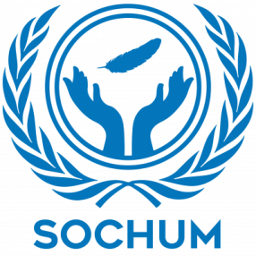
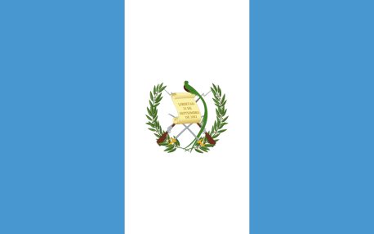
Country: Guatemala

Committee: SOCHUM

Delegate: Esma Yıldırım

Agenda Item: Ensuring the Rights of Indigenous Peoples in the Context of Climate Change and Environmental Degradation

Climate change and it’s negative impacts are one of the most significant challenges that we are dealing with today. Despite accounting for only 0.1% of global emissions, Guatemala is one of the countries which is most affected by climate change. The resulting droughts and irregular rainfall, along with the search for livelihoods, settlements, and mining activities carried out by the energy sector, along with deforestation and soil degradation, threaten the livelihoods, cultures, and rights of indigenous people, who constitute a large portion of the population. However, indigenous people are still underrepresented in environmental decision-making processes. The Guatemalan government emphasizes the importance of improving its climate policy and increasing the participation of indigenous people in environmental decision-making processes.

Guatemala is taking part in the protection of indigenous peoples' rights due to climate change and environmental degradation. Recently, in this respect, it presented its Enhanced Nationally Determined Contributions (NDC) in 2022. This statement is committed to a 22.6% reduction in greenhouse gas emissions by 2030. Karen Aguilar, manager of the REDD+ project-a solution against climate change, initiated by advocates of the UNFCCC (UN Framework Convention on Climate Change), to which Guatemala is a Party-said, "REDD+ is not just a mechanism to protect forests and avoid releasing carbon into the atmosphere but it aims at guaranteeing that populations that are living near or within these forests have a quality of life and the opportunity to participate in the conservation of the forests". OHCHR's (Office of the UN High Commissioner for Human Rights) objective is to advance a human rights-based approach to climate action by supporting the involvement of civil society in environmental decision-making, access to information, and effective remedies for victims, as well as conducting studies on violations of human rights by environmental degradation.

Guatemala is part of the efforts to protect indigenous peoples' rights in the face of climate change and environmental degradation. In this regard, in 2022, it submitted its updated Nationally Determined Contributions. The declaration is aimed at achieving a reduction of greenhouse gases by 22.6% by the year 2030. According to the manager of the REDD+ project, a climate change solution developed by supporters of the UNFCCC (UN Framework Convention on Climate Change) of which Guatemala is a member: "REDD+ is not only a mechanism for protecting forests and preventing carbon emissions from entering the atmosphere but also for ensuring that the populations living near or within those forests have a quality of life and the opportunity to participate in forest protection." OHCHR's (Office of the UN High Commissioner for Human Rights) work aims at facilitating a human rights-based approach to climate action. It supports the inclusion of civil society in environmental decision-making processes, access to information, and effective solutions for victims. The OHCHR conducts research to address violations of human rights brought about by environmental degradation.

Bibliography:
- https://verra.org/
- https://www.forestcarbonpartnership.org/
- https://ndcpartnership.org/
- https://www.undp.org/
- https://www.ilo.org/
- https://www.ohchr.org/
- https://www.un.org/

