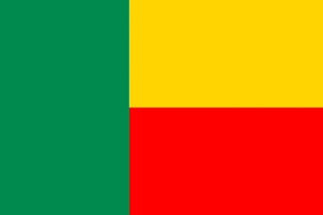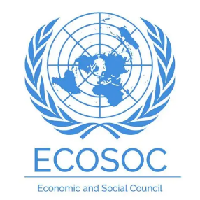

Country: Benin
Committee: ECOSOC
Delegate: Ela Bilge Çamurcuoğlu
Agenda Item: Tackling Youth Unemployment and Promoting Sustainable Economic Growth

Benin located in Western Africa, belongs to the African Union. In the African Union, ages between 15 and 35 are defined as “Youth”. Although Africa has the highest percentage of youth growth, unemployment rates are unstable as many young people have a job, however these jobs do not offer any job security or equality leading to an unsafe work environment. In Benin, the youth unemployment rate is 1.7% for females and 1.2% for males. This indicates a gender gap in employment.

The Republic of Benin tries to help young people by giving more efficient education and creating new business opportunities. To give an example in 2013, in partnership with UNDP, Benin Government launched a program called ‘Business Promotion Center’ which aims to support youth in creating their own enterprises and contribute to reducing youth unemployment. Moreover, the World Bank has given $41.3 million to support young people with little or no education and improve their job opportunities as well as technical and vocational training. Benin’s economy is based on agriculture and trade. It depends especially on cotton exports. Benin faces problems such as low income and effects of climate change. The Board of Directors of the African Development Bank Group has approved $30.25 million in 2025. This financing supports a pioneering initiative to bolster climate resilience and safeguard agricultural livelihoods in Benin. This initiative will protect 150,000 smallholder farmers against climate shocks in a country where agriculture employs seven out of ten people but remains at the mercy of an increasingly unpredictable climate.

We support NEETs to find employment in “Decent Work” because people have to know about their rights. We encourage females to have their businesses and become financially independent. We also believe that small businesses can help young people to start their own enterprises with security. The Benin Government tries to find solutions to reduce the economic impact of climate change. Benin does this within the framework of sustainable economic growth.

REFERENCES:
World Bank Group. (2025). Benin: More than 60,000 Vulnerable Youth Integrated into Agri-Food Value Chains and Wage Jobs.

World Bank Group Data. Total Population of Benin.

World Bank Group Data. Female Percentage of Total Population.

UN WOMEN Data. Country Fact Sheet | UN Women Data Hub Benin.

Georank. (2025). Benin's economy ranking: GDP & GDP per capita, debt.

DelegatePal. DelegatePal Benin.

TEDUTRAIN’25. ECOSOC Study Guide.

EDD Young Leaders (2016). Tackling youth unemployment: Solutions from Benin.

The African Development Bank Group. (2025). Benin: African Development Bank Approves Over $30 Million to Protect Farmers from Climate Shocks and Food Insecurity.

The Republic of Türkiye Ministry of Foreign Affairs. Benin’s Economy.

