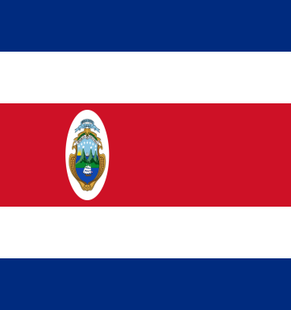
DELEGATION OF COSTA RICA
Committee : CSW
Country : Costa Rica

The Republic of Costa Rica was established in 1821. Our capital city is San Hose. The official language of Costa Rica is Spanish. Costa Rica’s population is around 5 million. Costa Rica is a small country in the middle of America continent. We have borders with Panama and Nikaragua. We became a meber of United Nations in Nowember second, 1945. We are one of the first members of UN, joined only 2 months later after it formed.
The agenda status of women is a huge problem in the World of 21th century. In order to find some solutions to the issue, many countries and people from all around the World have gathered together. We rank 3rd in the developing nations for gender equality. We have one of the highest levels of female political representation globally. The first female president was Laura Chinchilla Miranda, in 2010. We historically place large emphasis on promoting gender equality. The constituon pledges equal rights.
As the Republic of Costa rica, we have the following solutions;
-it should be legal for women to participate in elections
-the amount of payment that is being given to women and men should be equal
-there should be some punishmenst to the unequal treatment that is being made to men and women.
-There should be equal work given to the men and women that are in the same job.
-there should be special policies to the working mothers.
-the education should be equal tob oys and girls.
-the education system should be organized to teach that women and men are equal in rights.
We hope that this conferance will help us to solve the problems of our world. The Republic of Costa Rica is ready to act for an equal world.

