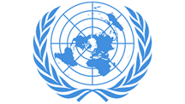

Country : Norway
Committee: United Nations Economic and Social Council
Topic : Tackling Youth Unemployment and Promoting Sustainable Economic Growth
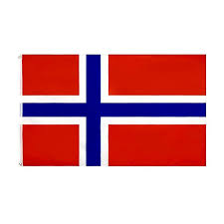

Because of the mismatch between the qualifications that young people have and the needed skills by the business world, the acceleration of technological advancements, the increase of automation, economic fluctuations, and the inexperience of young people, youth unemployment occurs. And because the Covid-19 pandemic period made it difficult employment for young people , the youth unemployment rate has increased.
Within the scope of Sustainable Development Goal 8, Decent Work and Economic Growth, Norway aims to reduce youth unemployment, and increase the quality of work life. Norway, within new education programs, works to better address the labor market’s needs. Norway intends to increase job opportunities.
Norway has taken many steps both nationally and internationally to deal with youth unemployment. Norway implements national programs, services, and policies such as the Youth Guarantee Program, Internship and Mentorship Programs, Active Labor Market Policies, Vocational Education and Training System, Apprenticeship Program, Career Guidance, and Counsuling Services. Norway contributes to various development programs to reduce youth unemployment with the United Nations and International Labour Organization (ILO). Norway stands out with its determination on inclusive and forward-looking labour markets.
Norway proposes that the committee should focus mainly on creating inclusive, innovative, and sustainable frameworks to reduce youth unemployment. Norway supports solutions such as Strengthening Education-to-Employment Pathways, Supporting Youth Entrepreneurship, Expanding Digital Skills Programs, and Enhancing International Cooperation. Norway believes that empowering youth through education, innovation, and digital job opportunities is key to achieve long-term economic stability and social cohesion.
References:
United Nations: https://www.un.org
World Bank: https://www.worldbank.org
European Commission: https://ec.europa.eu

