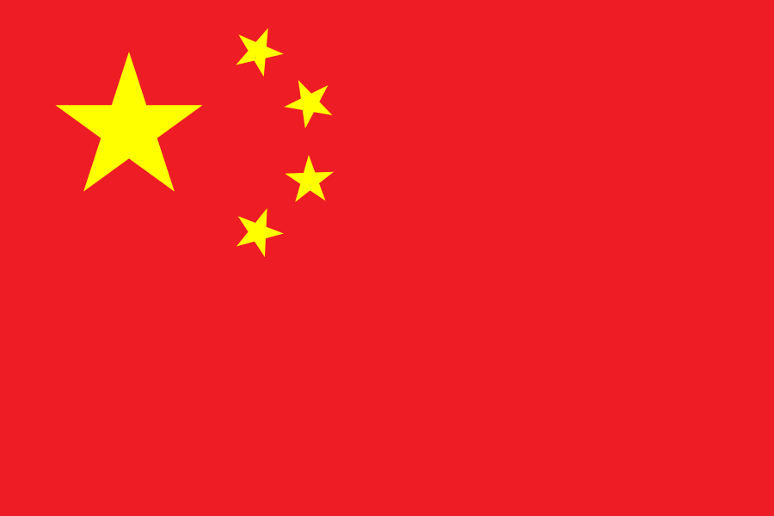
Committee: The United Nations Entity for Gender Equality and the Empowerment of Women (UNWOMEN)
Country: The People's Republic of China
Agenda Item: Strengthening protections around women's fundamental rights in the MENA region.

The People's Republic of China is a socialist republic with a unitary, single-party regime, governed by the Communist Party of China. As of 2021, China is the world's second-largest economy and also the world's largest exporter and second-largest importer of goods. Since the implementation of economic reforms in 1978, the Chinese economy has been one of the fastest-growing economies in the world. A nuclear-armed state, China has the world's largest active military force and the second-largest defense budget.
The People’s Republic of China recognizes the importance of strengthening the protection of women’s fundamental rights as an essential component of sustainable development and social stability. China acknowledges that women in the MENA region continue to face significant challenges in areas such as economic participation, access to education, healthcare, and social inclusion. Addressing these challenges requires a comprehensive, inclusive, and culturally sensitive approach that respects national sovereignty and regional diversity.
The Beijing Declaration and Platform for Action is a visionary agenda for the empowerment of women. It also serves as a reference framework for analyzing the situation of women worldwide and evaluating the efforts of states to empower women. The platform responds to the collective efforts of women and girls around the world fighting for gender equality and women's rights, and is a continuation of the international community's commitment to addressing civil, political, social, economic, and cultural inequalities.
To protect gender equality, China emphasizes the importance of education, economic empowerment, and legal protections for women. The delegation supports the development of women's professional skills and increased participation in decision-making processes, particularly in rural areas. It also encourages the sharing of best practices among countries under the auspices of the United Nations.
In conclusion, the People's Republic of China is dedicated to cooperating with the international community to achieve gender equality and women's empowerment through a balanced and inclusive approach, in line with the goals of the United Nations.

Zeynep Neva YILDIZ
The Delegate of China

