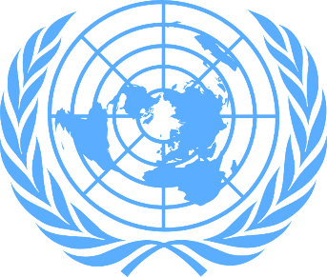
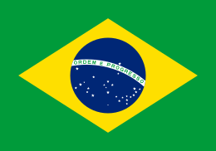

Chemical Controls on Industrial Manufacturing
Waste: Legal and Institutional Infrastructures

Country: Brazil
Committee: United Nations Environment Programme (UNEP)
Delegate: Nisa Küçük

Brazil, which has 60% of the Amazon Rainforest on its territory, It is described as the most biodiverse country in the world. It has one of the most various collections of flora and fauna on the planet.
The city of Cubatão, designated by the Brazilian government as an industrial zone partly because of its proximity to the Port of Santos, has come to be known as the "Valley of Death" and "The most polluted place in the world". The area, historically hosted many industrial facilities including an oil refinery from Petrobras and a steel mill from COSIPA. The operation of such facilities was done "without any environmental control" during the 1970s and 1980s, leading to heavy pollution and tragic events in the area. Since then, efforts have been made to improve environmental conditions in the region, including COSIPA's $200 million investment in environmental controls since 1993. Cubatão's headquarters, in 2000; recorded 100 micrograms of particles per cubic meter, recording 48 micrograms of particles per cubic meter of air. Probably due to trade liberalization, Brazil has a high concentration of pollution-intensive export industries. The searches, point to this as proof that Brazil is a pollution heaven.
Brazil uses sanitary landfills to organize its waste. Landfill is often seen as a last resort for waste disposal in European countries, instead of this they prefer waste-to-energy conversion systems. But Brazil prefers landfills and believes that they are efficient methods of disposal.
The solution required for waste management in Brazil is related to adequate funding and government funding. Even if insufficient funding, legislators and municipal officers are taking steps to improve their cities waste management systems. These individual efforts by municipal officers are being made in response to the country's lack of an all-encompassing law that governs waste materials. Although there are pickup services, they tend to focus on the south and southeast of Brazil. However, Brazil regulates hazardous waste materials such as oil, rubber and pesticides. In 2014, Brazil hosted the FIFA World Cup. As a result, a large amount of investment has entered the country, but resources are still lacking for waste management improvements. To fill the deficiency the lack of federal participation, the public and private sectors, as well as formal and informal markets, are developing potential solutions to these problems.
International organizations are also teaming up with local municipal officials, as in the case of the United Nations Environment Program (UNEP).
Since 2008, UNEP has been working with Brazil to create a sustainable waste management system that promotes the protection and protection of the environment as well as protecting public health.

This partnership is between UNEP and municipal officials who created the Green and Healthy Environment Project in São Paulo. With community involvement, the project can promote policies that drive environmental change. According to the UNEP report, the project has already gathered about sanitation research in Brazil. I would like to say that, through various partnerships and collaborations, specific cities are taking steps to manage their waste efficiently, but a more comprehensive and definitive decision must be made for the whole country to create a more sustainable future.
In my opinion, the solution to this situation is turning waste into resources, which is one of the EU's Roadmap for a Resource-Efficient Europe's target. Instead of collecting the waste in one place and store it, Brazil can solve this situation by burning the useless wastes, recycling the recyclable ones, filtering the polluted fumes coming out of the factories, and purifying the polluted water discharged into the sea.

