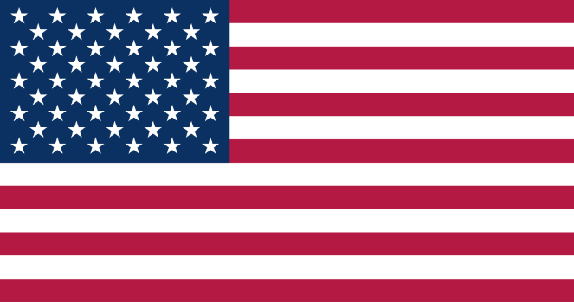
Committee Name: GA-4: SPECPOL
Agenda Item: Administration of Cultural Heritage
Member State: United States of America

United States of America is a nation located at the North America.It is a federal republic consisting of 50 states.It’s capital is Washington D.C. United States of America covers 9,833,517 km^2 area , and has a population of 343.119.938 people. In the first six months of 2025, United States of America has gained approximetely 127 billion dollars making it the predominant country on tourism economy. Current president of United States of America is Donald John Trump.
Rescently, administration of cultural heritages and artifacts are in a crisis situation. Problems are accuring upon misslocated artifacts, vandalism and terorism aiming cultural heritages, tourism and economy, education and sensivity towards cultural heritages, gathering resources to researches and balancing economic income and ownerships. During this committee, we are looking forward to find appliable solutions to these headlines in detail.
Increasing border controls in order to detect illicit trafficing, promoting global cooperation, organising bileteral agreements and conventions between countries to solve diplomatic problems, advancing preserving mechanisms towards cultural heritage; creating funds similar to The U.S. Ambassadors Fund for Cultural Preservation that ensures the protection of cultural heritage including historic buildings, archaeological sites, museum collections, paintings, manuscripts, and endangered Indigenous languages are perfect solution ideas for this committee.
Having these stated; we as the delegation of United States of America are looking forward to collaborations, ideas, debates, solutions, arguments, discussions, opinions, feedbacks, strategies, improvements, results and most importantly peace to both this committee and our world.
-Delegation of United States of America

Sources:
https://www.usa.gov
https://www.state.gov
https://www.census.gov
https://www.cia.gov
https://www.cia.gov/the-world-factbook/field/area/country-comparison/
https://www.usa.gov/about-the-us
https://www.census.gov/popclock/
https://www.state.gov/cultural-heritage-center/

