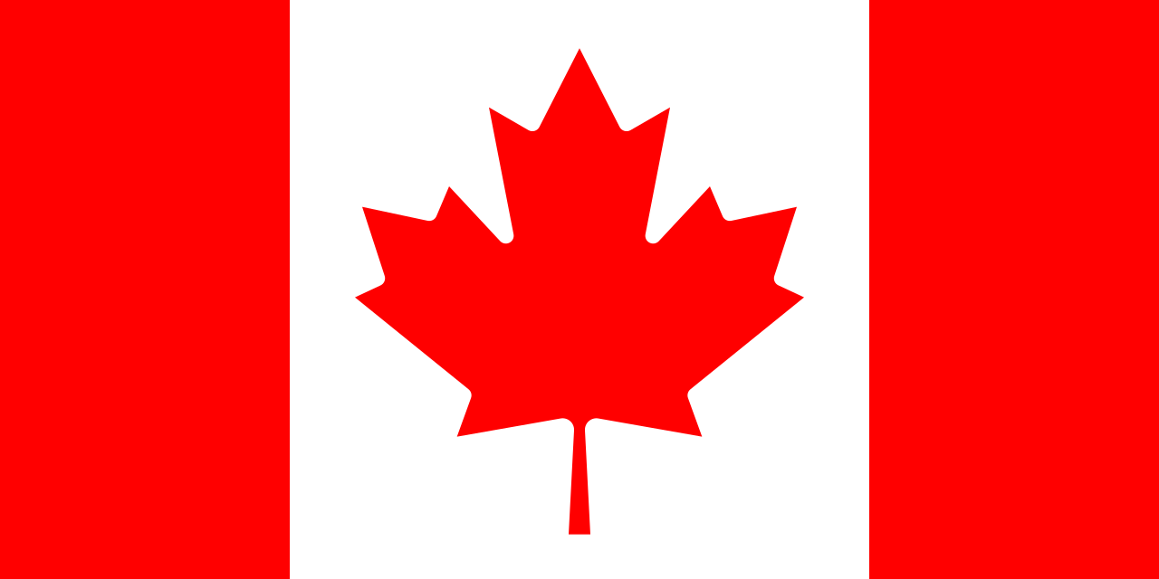 **Committee:** GA4: SPECPOL

**Country:** Canada

**Agenda Item:** Neocolonialism in the 21st

Century in the West African Region

Canada upholds values of sovereignty and self-reliance. Having our own colonial history, we recognize the complexity and difficulty of upholding true independence in any nation after colonial rule. Neocolonialism is economic, political or cultural influence by foreign powers, usually by former colonizers. In West Africa, neocolonialism is a large roadblock for the decolonization of the area. While classical colonialism includes direct control of a nation, neocolonialism operates indirectly. Neocolonialism shapes the cultural and social fabric of West Africa by reinforcing external culture and social means such as language, education, culture, etc. By reinforcing such means, neocolonialism aims to assimilate West African nations by integrating their own culture. For example, for many years France has attempted to dissolve African culture and implement its own by oppressive means. Another example is the ongoing use of the CFA franc, a currency created during French colonial rule and used by several West African countries. It is said that it limits economic sovereignty and allows France to have control over their previous colonies. France also has military units stationed in the Sahel region, while framed as a counter-terrorism operation, many Africans view it as a threatening presence. Countries like China and the U.S.A also have presence in the region, despite lacking any history of colonization. China has a more economic approach, funding many projects and giving loans, while the U.S.A has military presence for counter-terrorism as well as aid programs. The view of Chinese and American presence is relatively well compared to French presence. This creates a good comparison of what the people of Africa think of neocolonialism.

With institutions like Global Affairs Canada and the International Development Research Centre (IDRC), we aim to strengthen democratic institutions, sustainable development, and self-reliance in West Africa. Canada is also a strong advocate of African peacekeeping and security organizations, we believe that regional organizations should become active for any conflicts and instabilities without requiring foreign intervention. We mainly supports African sovereignty, responsible investment and local development in the area. In order to achieve these values, Canada funds governance programs that strengthen public institutions, elections, and judicial systems to reduce foreign dependency and build sovereignty. We make efforts to support inclusive growth, not external control.

We invite all delegates to work together with commitment to combat neocolonialism, uphold true independence, and support sustainable development across West Africa for a fair future.

References:

<https://www.un.org/en/decolonization>  
<https://www.britannica.com/topic/neocolonialism>

<https://www.worldbank.org/en/news/feature/2020/06/19/africas-path-to-sustained-development>

<https://www.transparency.org/en/news/foreign-investment-and-corruption-in-africa>

<https://www.aljazeera.com/news/2023/1/20/frances-military-influence-in-west-africa>

<https://www.international.gc.ca/world-monde/issues_development-enjeux_developpement/africa-afrique/index.aspx?lang=eng>

<https://www.cfr.org/backgrounder/chinas-role-africa>

<https://www.brookings.edu/research/assessing-us-strategy-in-africa/>