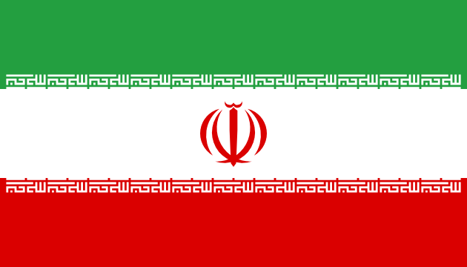

**Country:** Islamic Republic of Iran

**Committee:** United Nations Children’s Fund (UNICEF)

**Agenda Item:** Abolishing Child Marriages

**Delegate**: Elif BOZ

The Islamic Republic of Iran is one of the most powerful Islamic nations in the world, with a population of roughly 90 million and an area of 1.6 square kilometers. Ninety percent of Iran's population are Shia Muslims. Iran is a country in Middle East, bordering the Gulf of Oman, the Persian Gulf, and the Caspian Sea, between Iraq and Pakistan since 1979. Capital city of Iran is Tehran and its president is President Masoud PEZESHKIAN and the supreme leader of Iran is Ali Hoseini-KHAMENEI.

In the Islamic Republic of Iran, according to civil law, the marriage age is 13 for girls and 15 for boys but with court approval, children can marry at even younger ages. Iran’s civil law accords with sharia law. This is one reason for marriage age. Some UN committees and some establishments say, “The thing Iran's made of the topic of marriage age refuses International Human Rights Law, Early marriage is especially dangerous for the education, freedom, health, and legal rights of girls.” but we disagree with this. Iran believes that marriage, when done with family support and proper legal approval, can be safe and respectful. Not all early marriages are forced or harmful. In many cases, they are based on family decisions that aim to protect the child’s future, especially in rural or traditional communities.

At the same time, Iran is aware of the risks that may come from forced or early marriage. That is why the government is working to support education, especially for girls, and to prevent harmful practices. Social workers and courts carefully review marriage cases involving minors to protect their health and rights.

Iran believes that to reduce the harmful effect of child marriage, we must focus on education, support families, and respect cultures and traditions. The Islamic Republic of Iran is open to working with UNICEF and other countries to find respectful and effective solutions to protect children and their rights.

**BİBLİOGRAPHY**

<https://www.cia.gov/the-world-factbook/countries/iran/>

<https://data.un.org/en/iso/ir.html>

<https://www.rferl.org/a/iran-child-marriages/31420642.html>