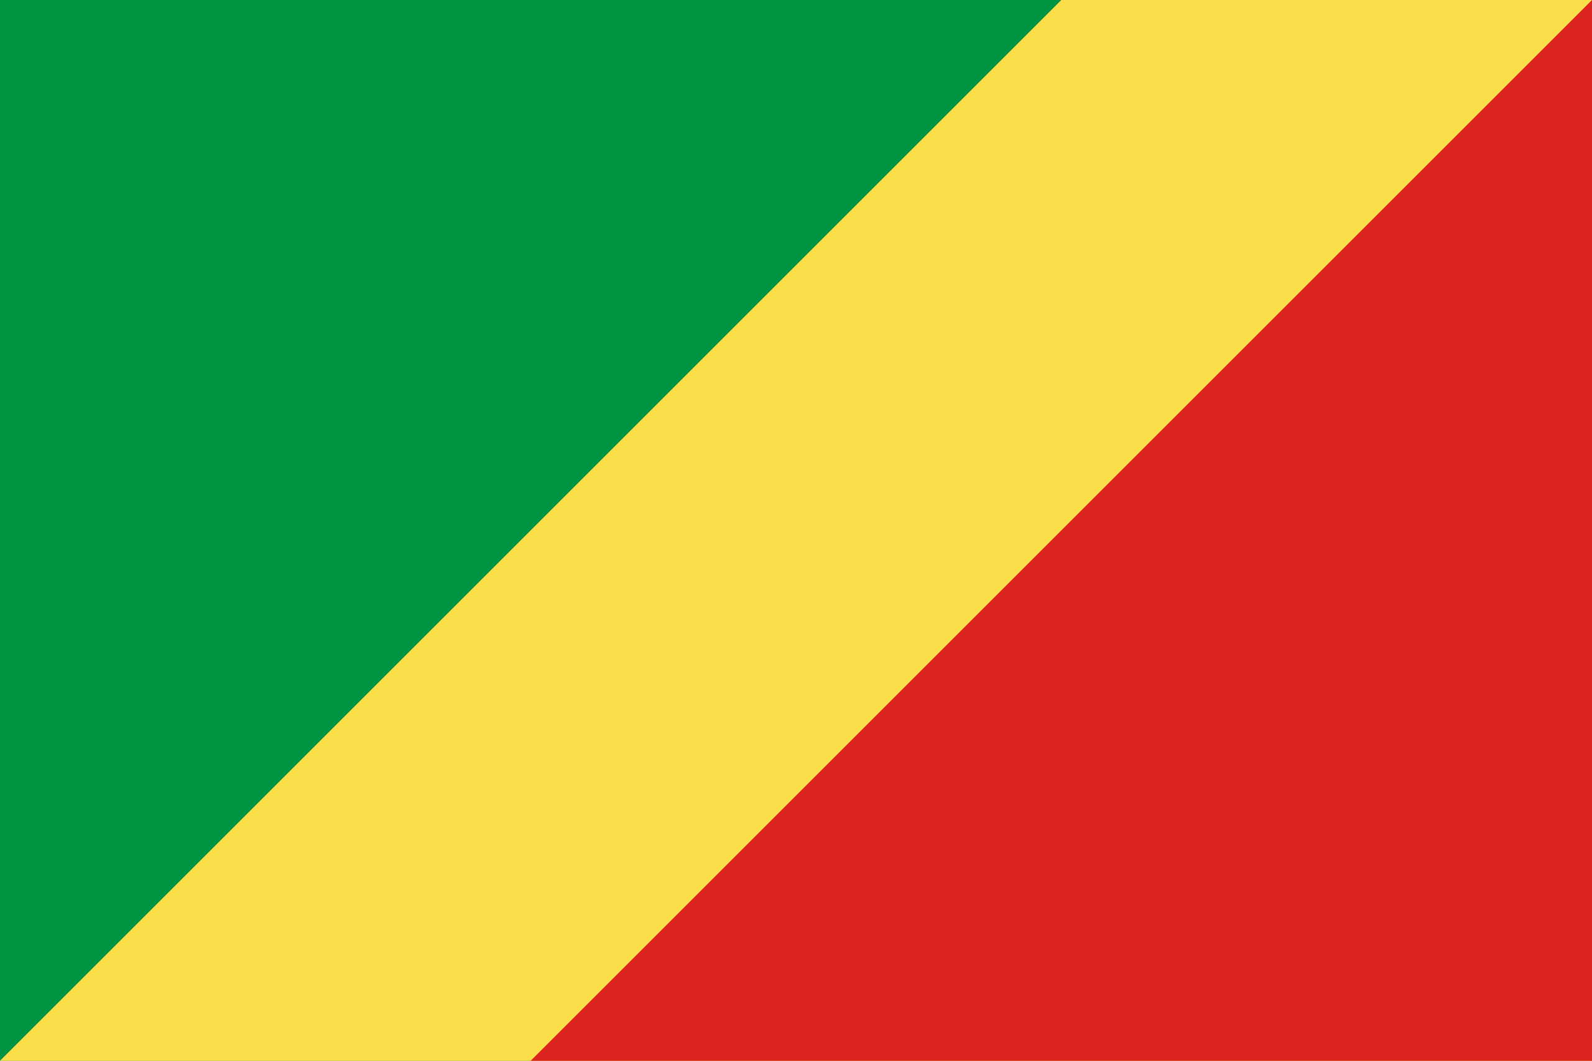

***Committee Name:*** United Nations Educational Scientific and Cultural Organization

***Topik/Agenta: (1)*** Promoting Sustainable Education for Climate Action

***Topik/Agenta: (2)*** Strengthening the Protection and Promoting of Intangible Cultural Heritage

***Country:*** Republic of Congo  ***Delegate’s Name:*** Rüzgar Nil Cihan

**Topik/Agenta: (1)** Promoting Sustainable Education for Climate Action

The Republic of the Congo acknowledges that climate change is a major threat to our environment, our future, and also our quality of life. Located in the Congo Basin, which spans approximately 3 million square kilometers and hosts the world’s second largest rainforest, and as a country that has lived alongside nature for many years, we are directly affected by deforestation and ecological degradation. The Republic of the Congo believes that sustainable education plays a significant role, especially in mobilizing youth around climate change, environmental issues, and global challenges. Our government has signed various projects and agreements to incorporate environmental and climate-related education into the national school curriculum. With the support of UNESCO and the French Development Agency (AFD), our teachers have received training in specific areas and have been educated to pass this knowledge on to future generations. Furthermore, on September 19, 2023, the Republic of the Congo committed to UNESCO’s “Greening Education Partnership” initiative to establish climate-sensitive education systems. This commitment is a political pledge aimed at achieving comprehensive goals in education, health, and youth in West and Central African countries. The Republic of the Congo officially endorsed this commitment at an event held in Brazzaville in April 2023. The event was attended by the government of the Republic of the Congo, regional economic communities, as well as United Nations agencies such as UNESCO, UNFPA, and WHO. This commitment aims to improve and enhance young people's access to education, health, and social services. The Republic of the Congo calls for increased international cooperation to promote inclusive and culturally sensitive climate education programs across Africa. Although school enrollment rates are high in urban areas, due to infrastructure problems, lack of materials, and insufficient teaching staff in rural areas, the establishment of regional education centers is requested. In conclusion, the Republic of the Congo is taking concrete steps to implement education related to climate change. In cooperation with UNESCO and other member states, we aim for education to be a strong tool not only for academic development but also for environmental responsibility and sustainable climate action.

***Topik/Agenta: (2)*** Strengthening the Protection and Promoting of Intangible Cultural Heritage

The Republic of the Congo acknowledges that strengthening the protection and promotion of intangible cultural heritage is a very important factor both for the country not to lose its unique characteristics and for the continuation of the cultural heritage that has lasted for many years.As a country rich in traditional music, dances, languages, and also indigenous knowledge, we strongly emphasize our commitment to the protection and celebration of our rich culture that continues to be lived. One of our country's cultural values known as Congolese rumba was officially included in UNESCO’s Representative List of the Intangible Cultural Heritage of Humanity on 14–15 December 2021, by both DRC (Democratic Republic of the Congo) and the Republic of the Congo, and we are proud of this.The Republic of the Congo has ratified the 2003 Convention for the Safeguarding of the Intangible Cultural Heritage, especially in rural and indigenous communities, and is actively working with UNESCO and regional partners to document, transmit, and protect traditional practices.The Republic of the Congo thinks that culture should not only be protected through speech and rituals, but also by spreading cultural education in schools, creating awareness among the youth and ensuring that future generations learn about our culture.As we live in a digital world today, we believe that our culture should not only be in books, but also be transmitted to future generations through the digitalization of oral traditions and folk knowledge.As the Republic of the Congo, we call for financial and technical support to developing countries on the protection of cultural heritage, promotion of fair representation of African heritage in global narratives, and support of participatory policies that respect cultural diversity and indigenous voices.For the Republic of the Congo, protecting intangible cultural heritage is not only about preserving the past, but also an investment in a peaceful, culturally rich, and sustainable future.