Committee: World Health Organization (WHO)
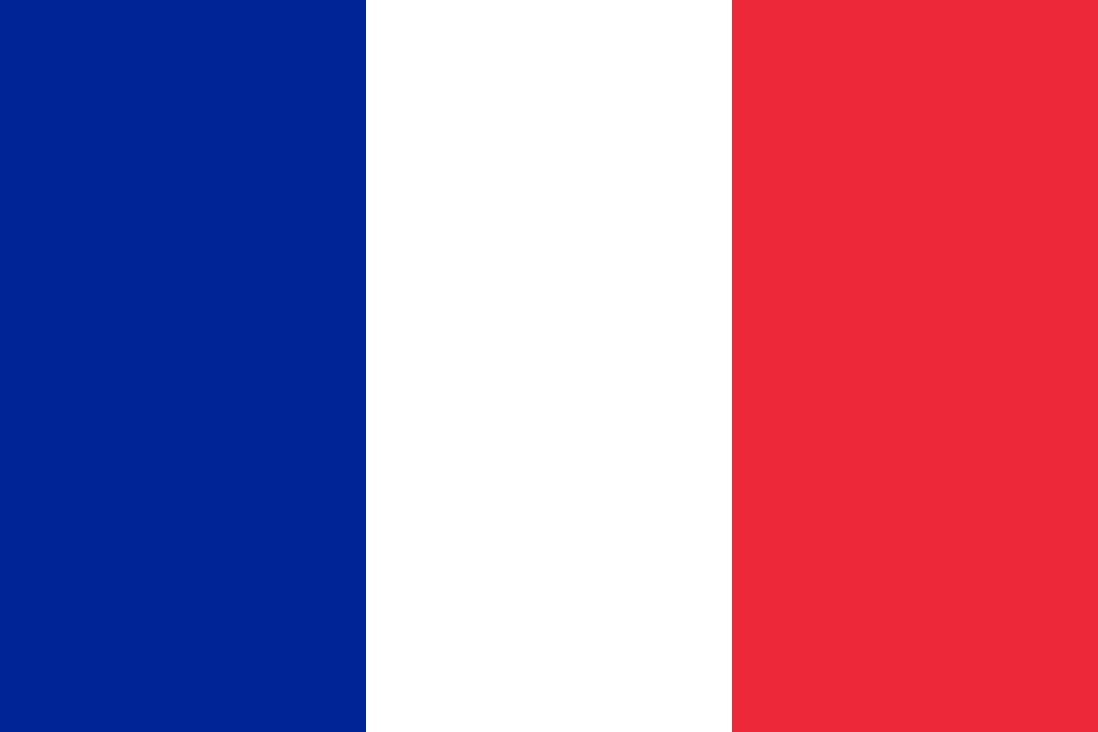
Country: France
Agenda item(s): Preventing the second COVID-19 wave in the African Regions
Pandemic is an epidemic that occurs in many continents and regions around the world. In the past few months, the world is in a war with a COVID-19 pandemic. It is a thought that it was transmitted by a bat form a market selling sea and meat products called Hunan in the city of Wuhan, China. The time when COVID-19 became an epidemic was when China reported it to the World Health Organization on December 31, 2019.
The COVID-19 pandemic has severely affected all of the people and countrıes around the world. Some had great difficulty to fight against this pandemic. Contrary to what may be expected, countries in African Region are less affected. At the beginning of May, the number of COVID-19 cases in Africa was lower than in other regions of the world. However, in most African countries, medical systems are poorly equipped to handle a massive epidemic. Thus, Africa needs massive help to overcome these challenges. Also the consequences of a probable second wave will be awful in every way. European countries should be called to take action just like France did.
The Republic of France is regarded as the heart of Europe with its architecture, cultural richness and works. It is highly developed in terms of tourism, thanks to its historical and natural beauties. It is a member of the UN, EU, NATO, OSCE, G-8, G20, UFM and many more. As France, we are determined to increase our assistance to Africa. In order to rule this type of help, France has decided to redirect projects so that those in need can fight with the spread of COVID-19.
The international community has prepared various packages including a debt monotonetim to relieve the economic and financial burden in which France has actively participated. New agreements should be prepared to arrange these funds. And if correctly seized, it might be the opportunity to strengthen African-Europe partnership.

