**POSITION PAPER**

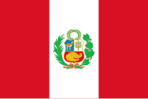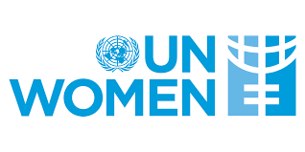

**Committee: United Nations Entity for Gender Equality and the Empowerment of Women UNWOMAN**

**Country: Peru**

**Agenda Item:** Addressing Femicide Through Legislative Action and International Cooperation.

**Peru is located in South America. Ecuador, Bolivia, Chile, Colombia and Brazil are Peru’s border neighbors. Lima is the capital of Peru. Peru has about 1,285,216** km² area. Peru is the 3rd largest country in South America.

In Peru 258 women were killed in 2023.This is the highest level of femicide in Peru.All around the World 85,000 women and girls were killed in 2023. Partners are the biggest cause of femicide . Africa has the highest level of femicide and education level is the lowest.

We want to to prevent violence to women and children. We have Ministry of Women and Vulnerable Populations for helping victim of violence and promoting gender equality in Peru. As Peru government, we planned to prevent violence to women and children . This plan has education campaign and we support victims .

Peru has legal regulations in place that recognize violence against women as a crime and protect victims. The "Law Against Violence Against Women,"was enacted in 1996, aims to prevent violence and discrimination against women by Peru government.

We can solve this problem with education. We need to educate people starting from the children. Plus we should organize campaigns to arouse awareness of people. Africa has the lowest education level so femicide level is very high here.If we can educate people in Africa their femicide level will become lower.We are doing our best to stop femicide in Peru. However, whatever we do is not enough for this .We need to make strong laws for femicide.