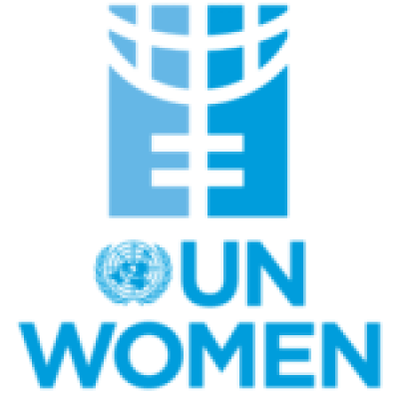

**POSITION PAPER**

**Committee:** UNWOMEN

**Country:** The Islamıc Republıc of Iran

**Agenda Item**: Addressing Femicide Through Legislative Action and International Cooperation.

**The Islamic Republic of Iran** has an area of 1,648,195 square kilometers and a population of 89 million. Behaviors against women's rights, especially femicide, have a bad impact on Iran's global reputation. The society's indifferent behavior towards women's rights is negatively perceived by other countries. Because women's rights are considered as modernity and vision.

As the Islamic Republic of Iran, we accept the problem of femicide and women's empowerment. We are taking important steps such as empowering women, protecting their rights and legal guarantees.  
  
**The Economic and Social Council Commission (ECOSOC)** cooperates with the **Commission on the Status of Women (CSW) [Iran-North America]**. Following the ongoing oppression of women in the Islamic Republic of Iran and the violent suppression of protests following the death of Mahsa Amini, the **United Nations Economic and Social Council (ECOSOC)** removed Iran from the **Commission on the Status of Women (CSW)** until 2026. The Convention on the Elimination of All Forms of Discrimination against Women **(CEDAW)**, which the Islamic Republic of Iran is not a party to, restricts women's rights at the international level. As a result, the Draft Law on Preventing Violence against Women and Promoting Security, issued by the Islamic Republic of Iran, aims to prevent violence against women and increase the security of victims. The new draft law includes various measures to prevent women from becoming victims of violence. However, the enactment process of this draft law has not been completed.

**The Islamic Republic of Iran** has made some legal arrangements, but it has not established an effective and independent system that truly protects women. Policies towards women have taken effective steps, especially by enacting laws that include deterrent punishments for those who commit femicide and those who fail. Many developments have been made in social areas. As of **2017**, **22** shelters have been establish throughout Iran. **15** of these centers are managed by the private sector, while the rest are managed by the state. These shelters provide shelter for homeless women and victims of domestic violence.