Position Paper

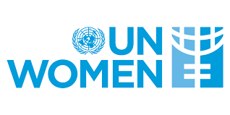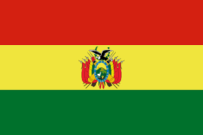

Committee: UNWOMEN

Country:Bolivia

**Agenda Item:** Addressing Femicide Through Legislative Action and International Cooperation

As of March 2025, Bolivia’s population has reached **12.7 million people** and its has **6.28 million females** living in Bolivia whitch means women constitute is about **49.9%** of the total population.

The UNWOMEN Committee is a very important topic for Bolivia because, like in other countries, incidents of abuse against women are prevalent. As a result, many women are unable to live freely.

Bolivia has some laws for woman rights to live freely such as law 243: This law criminalizes political violence against women, such as harassment and discrimination, and imposes penalties ranging from 2 to 8 years in prison. Such as law 348: This comprehensive law defines 16 types of violence against women, including physical, sexual, and psychological abuse. It mandates that perpetrators face a minimum of 30 years in prison without parole for femicide. And because of this the violance of women reports has gone up to 206 and whit that much reports the number of women thats living freely increased.

Even thought we did all of this some of our countrys womens still getting abuse thats why we want your help cause with your help we can find and help more women not just in Bolivia in all of the World to help them live freely. And to help them we can make laws that will make them stop doing women abuse.