POSITION PAPER

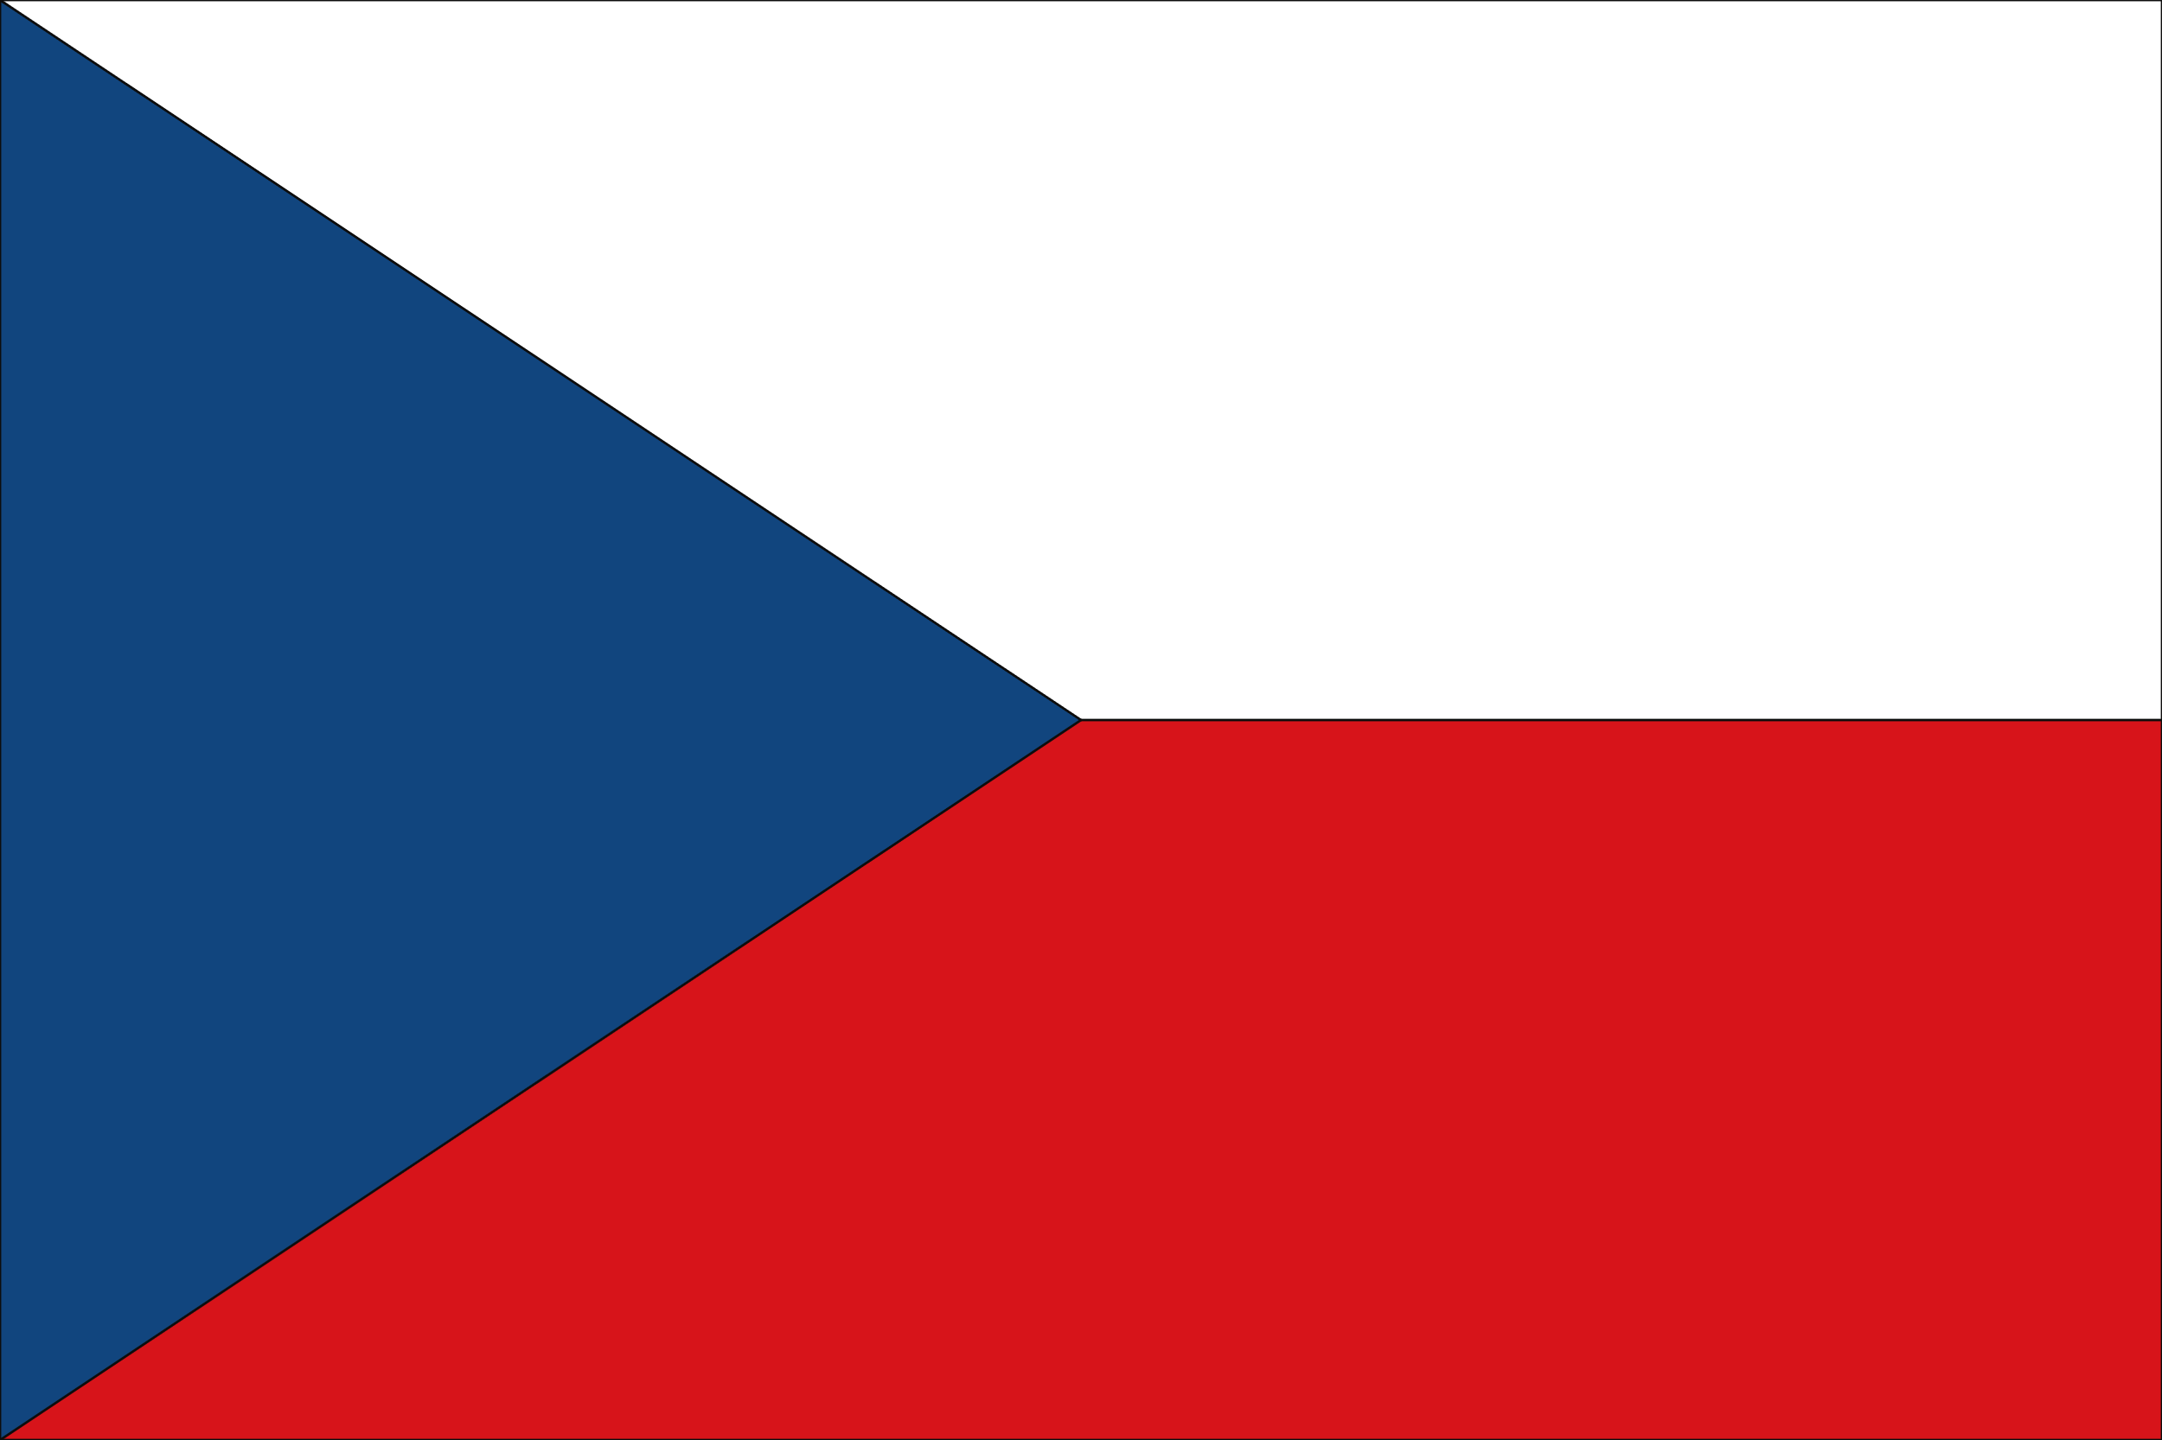

**Committee:**[**United**](https://dictionary.cambridge.org/tr/s%C3%B6zl%C3%BCk/ingilizce-t%C3%BCrk%C3%A7e/united)**Nations**[**Economic**](https://dictionary.cambridge.org/tr/s%C3%B6zl%C3%BCk/ingilizce-t%C3%BCrk%C3%A7e/economic)[**and**](https://dictionary.cambridge.org/tr/s%C3%B6zl%C3%BCk/ingilizce-t%C3%BCrk%C3%A7e/and)[**Social**](https://dictionary.cambridge.org/tr/s%C3%B6zl%C3%BCk/ingilizce-t%C3%BCrk%C3%A7e/social)[**Council**](https://dictionary.cambridge.org/tr/s%C3%B6zl%C3%BCk/ingilizce-t%C3%BCrk%C3%A7e/council)

**(ECOSOC)**

**Country: Czech republic**

**Agenda Item:Promoting**[**Gender**](https://dictionary.cambridge.org/tr/s%C3%B6zl%C3%BCk/ingilizce-t%C3%BCrk%C3%A7e/gender)[**Equality**](https://dictionary.cambridge.org/tr/s%C3%B6zl%C3%BCk/ingilizce-t%C3%BCrk%C3%A7e/equality)[**and**](https://dictionary.cambridge.org/tr/s%C3%B6zl%C3%BCk/ingilizce-t%C3%BCrk%C3%A7e/and)[**Women**](https://dictionary.cambridge.org/tr/s%C3%B6zl%C3%BCk/ingilizce-t%C3%BCrk%C3%A7e/women)**'**[**s**](https://dictionary.cambridge.org/tr/s%C3%B6zl%C3%BCk/ingilizce-t%C3%BCrk%C3%A7e/s)

**Empowerment**[**in**](https://dictionary.cambridge.org/tr/s%C3%B6zl%C3%BCk/ingilizce-t%C3%BCrk%C3%A7e/in)[**Emerging**](https://dictionary.cambridge.org/tr/s%C3%B6zl%C3%BCk/ingilizce-t%C3%BCrk%C3%A7e/emerging)**Economies.**

The Czech Republic, established on January 1, 1993, is a landlocked country located in Central Europe. It shares borders with Poland to the north, Slovakia to the east, Austria to the south, and Germany to the west. Its capital is Prague, which is also the largest city in the country. The Prime Minister of the country is Petr Fiala, and the President is Petr Pavel. The country follows a bicameral parliamentary democracy. We, as the Czech Republic, are also aware of this global problem. We want to do por best for this. We support allcountries to be solution-oriented on this issue.

Promoting gender equality and empowering women in developing economies holds significant importance in international relations because gender equality is directly linked to global development, peace, and security. Many international organizations see women's rights and gender equality as critical components of development in emerging economies. In the case of the Czech Republic, this issue not only affects domestic policies but also influences foreign policy and international cooperation. The Czech Republic is a member of the European Union (EU), which has developed important laws on gender equality and launched various programs to strengthen women's rights. Along with other European countries, the Czech Republic has developed strategies to increase women's participation in the workforce, ensure equal pay, and promote women's presence in leadership roles. It has also introduced programs to support women in starting and growing businesses and encourages greater involvement of women in political and public life.

Promoting gender equality and empowering women in developing economies is a cornerstone of global development goals. However, there are several universal challenges in this field, such as women being underrepresented in STEM (Science, Technology, Engineering, and Mathematics) fields compared to men, having insufficient representation in political and economic decision-making processes, and facing gender-based violence. Additionally, many countries lack the necessary legal and institutional mechanisms to ensure gender equality, or these mechanisms are not being enforced. The Czech Republic has developed equal strategies and programs at both national and international levels to address these global issues. The "2021-2030 Gender Equality Strategy," adopted in 2021, includes 26 strategic goals and more than 200 specific tasks across eight thematic areas, such as work, decision-making, security, health, society, foreign relations, and care. The aim of this research is to support gender equality in innovation fields. On the international stage, the Czech Republic has supported human rights and democracy in 11 countries, including Ukraine, Georgia, and Armenia, through its "Transition Promotion Program" launched in 2005. This program focuses on civil society, freedom of expression, political participation, rule of law, equality, and non-discrimination. Furthermore, the Czech Republic aligns with the United Nations Sustainable Development Goals (SDGs), especially Goal 5 (achieving gender equality and empowering all women and girls).

The United Nations Economic and Social Council (ECOSOC) plays a global leadership role in promoting gender equality and empowering women in developing economies. The ECOSOC-affiliated Commission on the Status of Women (CSW) sets global standards for women's rights and gender equality and develops concrete action plans in annual meetings. In 2025, on the 30th anniversary of the Beijing Women’s Conference, an urgent call for action to empower women was made. ECOSOC also adopted the 'gender mainstreaming' strategy to integrate gender equality into the entire United Nations system. This strategy aims to eliminate gender inequalities by considering the equal experiences of both women and men. To support female entrepreneurship, increasing access to microfinance and digital finance resources is necessary. Additionally, training programs should be launched to improve women's digital skills, and the digital divide must be closed. Legal reforms should be made to combat gender-based violence, and protection and rehabilitation services for victims of violence should be strengthened. Local health infrastructures should be enhanced to increase women's access to health services, and awareness about sexual and reproductive health should be raised. Social security systems, particularly for women without job security, should be improved, and their economic independence should be supported. Leadership programs and incentives should be offered to increase women's participation in decision-making processes, and gender equality education should be widespread. These steps will support women's empowerment and contribute to tangible progress toward gender equality.