**POSİTİON PAPER**

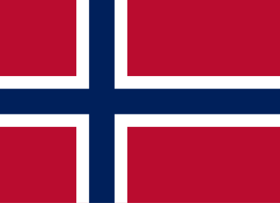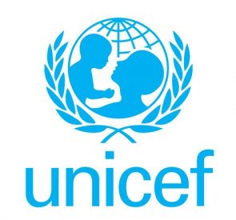

**Committee: UNİCEF (United Nations Children's Fund)**

**Country: Norway**

**Agenda item: Abolishing Child Marriages**

It is our responsibility to ensure that the future generations will have a bright future and we all must work towards this goal.

We are carrying out our work on this important issue by the Norwegian delegation. Before 2018, people were allowed to get married at the age of 16 and under. This law paved the way for forced underage marriages. However, we prevented this problem by introducing new regulations. In 2018, we took steps to prevent child marriages by enacting the law that prohibits people to get married under the age of 18 under any case. We also established institutions such as Barnevernet to solve this problem. Barnevernet is Norwegian Child Welfare Service that works on protecting children and their rights.

While child marriage is not a local issue in Norway, it seems that child marriages can still be seen among the immigrants residing in the country. However, Norwegian authorities continue to prevent these situations and protect children’s rights. The country’s regulations on this issue are not only to ban child marriages, but also to prevent these and similar practices. It is one of Norway’s main goals to emphasise that child marriages should not be considered normal, especially since such situation is a common practice in immigrant communities.

**Referancess:**Norwegian Directorate for Children, Youth and Family Affairs. (2018). Marriage law amendments: Minimum marriage age raised to 18. Retrieved from https://www.bufdir.no

Norwegian Government. (n.d.). Barnevernet – Child Welfare Services. Retrieved from https://www.regjeringen.no/en/topics/families-and-children/child-welfare/id2006135/

UNICEF. (n.d.). Child marriage. Retrieved from https://www.unicef.org/protection/child-marriage

UNFPA. (2021). Child Marriage in Humanitarian Settings: Spotlight on the Situation of Girls in the Middle East and North Africa. Retrieved from https://www.unfpa.org

Norwegian Ministry of Foreign Affairs. (n.d.). Norway’s International Development Policy on Gender Equality. Retrieved from https://www.regjeringen.no/en/topics/foreign-affairs