**POSITION PAPER**

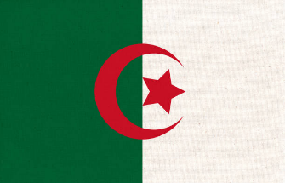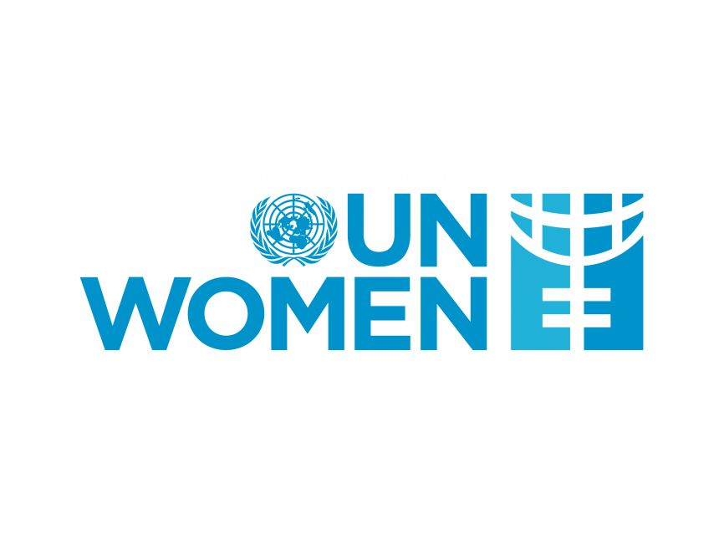

**Committee: UNWOMEN**

**Country: Algeria**

**Agenda Item: Addressing Femicide Through Legislative Action and International Cooperation**

We are faced with femicides, which are a serious problem that has emerged along with gender inequality. Even though some countries tend to normalize this issue, we want people to realize the magnitude of the problem. For this reason, we are trying to make our laws more effective for a brighter future.

As Algeria, we are aware of the issue of femicide, which is very common all over the world. There are official regulations on femicide in our country, but there are still some deficiencies in practice. A few of these constitutions are the 2015 constitution. This constitution was a law that planned to apply severe sanctions against domestic violence and street harassment, but this law was not fully implemented. Similarly, we passed a similar law in 2019. This constitution aims to protect women from all kinds of violence everywhere and under all conditions, and if such a situation occurs, it foresees free shelters, care centers, appropriate application channels and free legal aid. However, despite these constitutions, femicides continue, although they have decreased.

As a country like Algeria, we are aware of the importance of femicide and we are ready to provide all the support we can to stop it.